ACTIVATE SONDHEIM:

Into the Woods

The Digital Theatre+ Activate series provides teachers with a variety of
ready-made materials including quizzes, relationship maps and plot summary worksheets for teaching a specific text. This guide will help you save time creating engaging and relevant activities for your students.

Content and activities in this pack have been extracted and adapted from our Into the Woods Study Guide written by Gareth Valentine. The study guide can be used as a source for revision and additional information as you use these activities in your classroom.

In this guide you will find:

Relationship Maps
- Version 1
- Version 2
- Version 3

Stephen Sondheim Worksheet
- Stephen Sondheim Worksheet with answers

Worksheet 1 – Plot Summary
- Worksheet 1 – Plot Summary with answers

Worksheet 2 – On Music
- Worksheet 2 – On Music with answers

Quiz Questions
- Quiz questions with answers
- Quiz questions – multiple choice
- Quiz questions – multiple choice with answers

Suggested Assignments

RELATIONSHIP MAPS

Our relationship maps provide you and your students with a visual representation of how the characters in the play are all connected. These can be given to your students to help further understand character relationships while reading the text or can be used as a revision tool and for assessments.

On the following pages, you’ll find three versions of the relationship map:

Version 1: Relationship map showing character names and relationships
Version 2: Relationship map without character names
Version 3: Relationship map without relationship descriptions.

All images for our relationship maps have been taken from our production of Into the Woods.

RELATIONSHIP MAP: VERSION 1

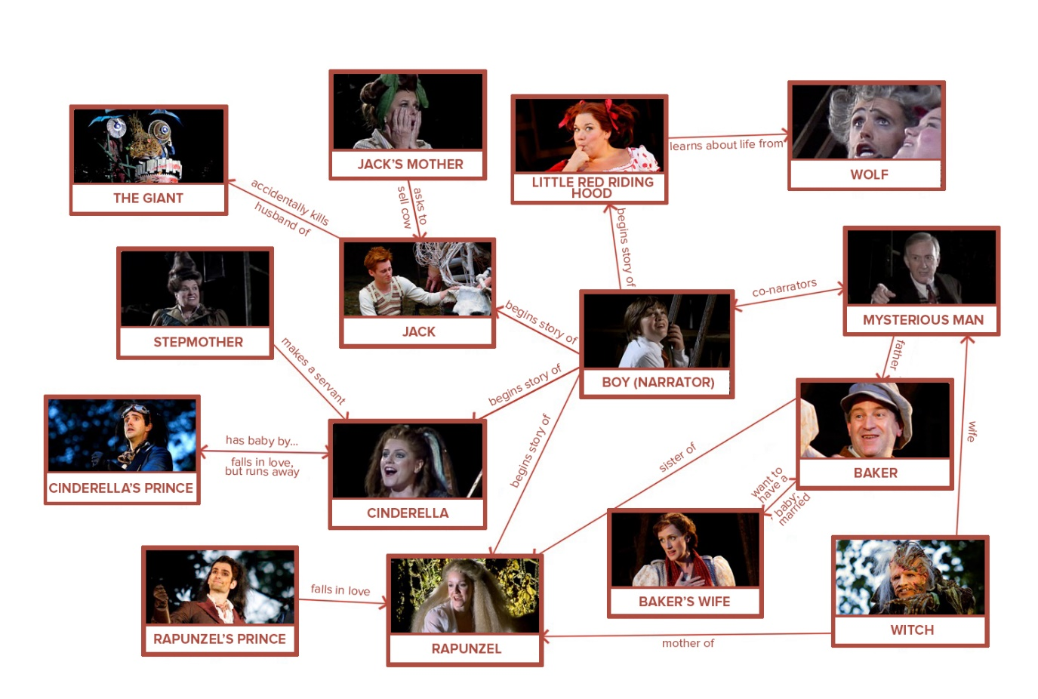

RELATIONSHIP MAP: VERSION 2

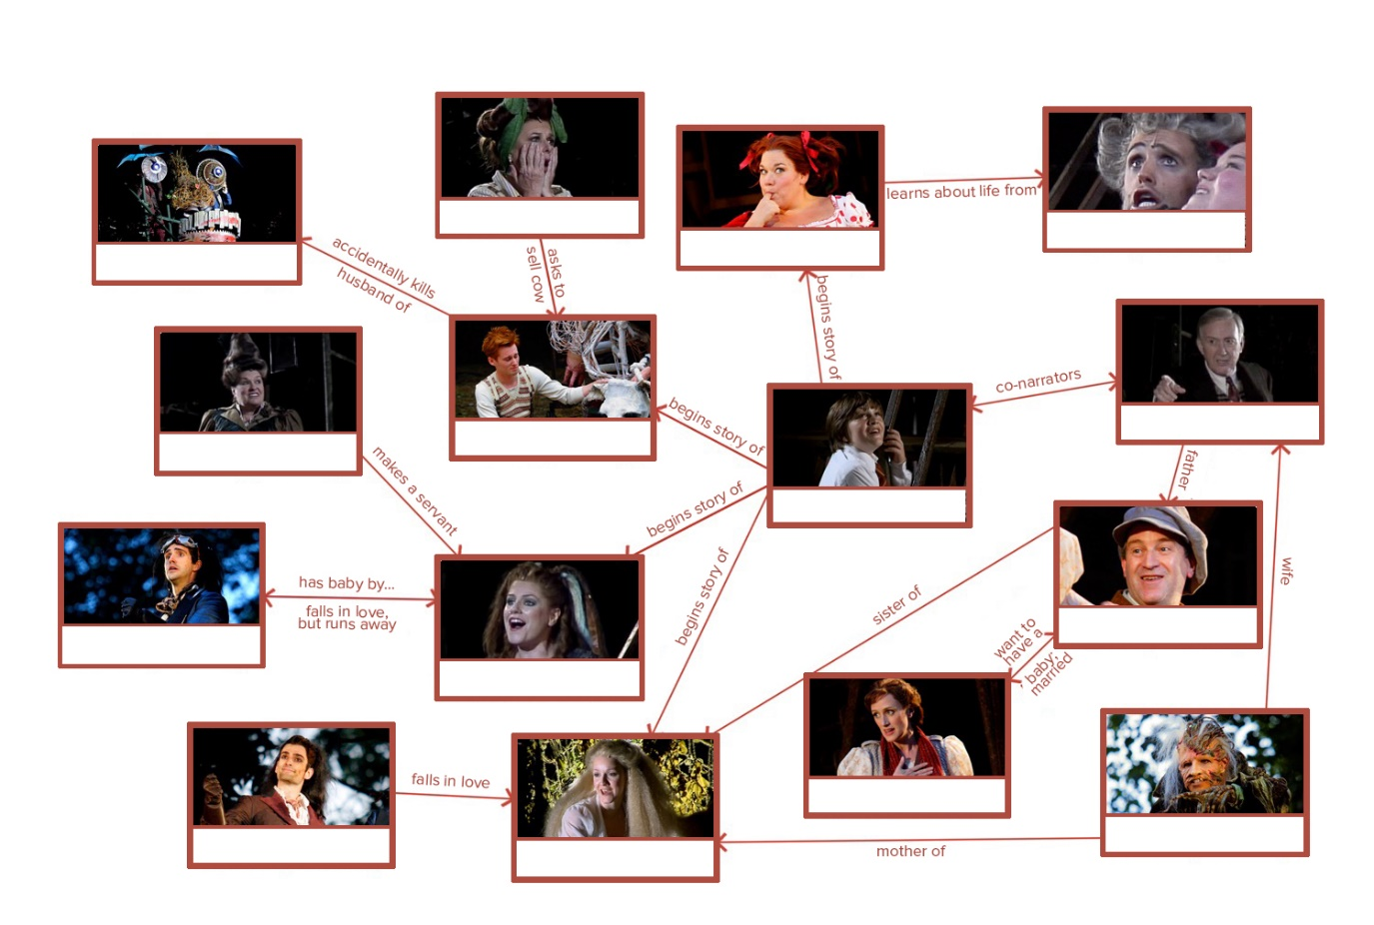

RELATIONSHIP MAP: VERSION 3

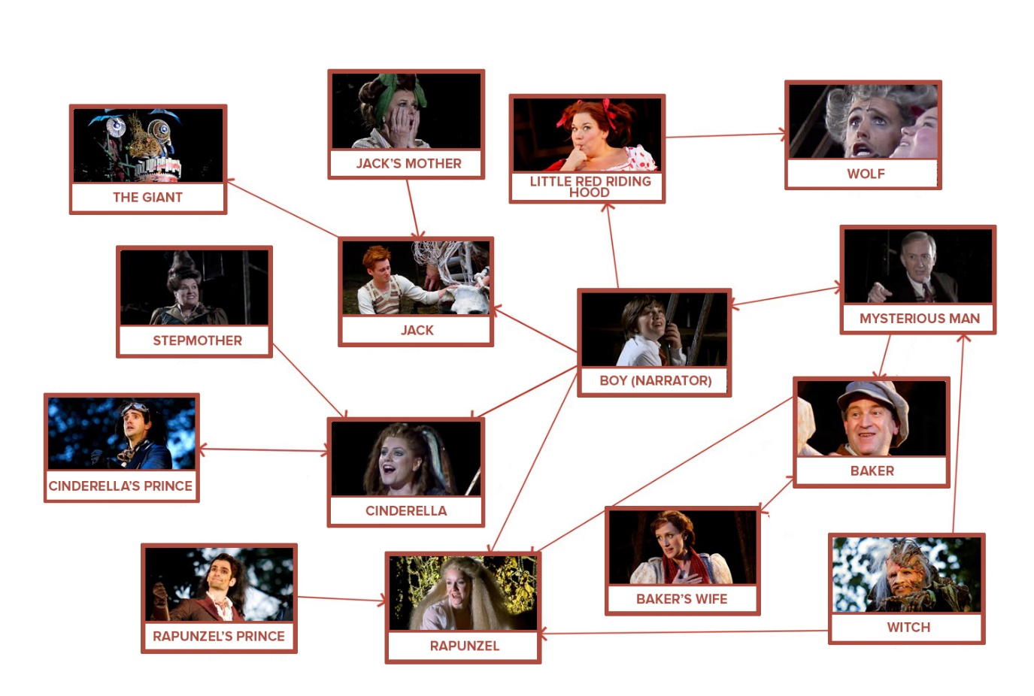

STEPHEN SONDHEIM WORKSHEET

1) In what way are Stephen Sondheim’s musicals diverse?

2) Match the Sondheim musical to the description of music from the show.
Musical | Description
Pacific Overtures | Contains a vaudeville showtime chorus
Sweeney Todd | Contains a 60s ballad
Assassins | Contains many ‘period’ songs
Company | Contains a Victorian ballad
Follies | Borrows from Gilbert and Sullivan

3) In the late 1950s, for which two shows did Sondheim write lyrics but not music?

4) How did the global popularity of Sondheim’s music compare to Andrew Lloyd Webber’s music?

5) To whom does Sondheim regularly give full and unqualified credit?

6) To what does Sondheim compare his role as a songwriter/lyricist?

7) What did Sondheim once say was the ideal way to write a musical?

8) Complete each of Sondheim’s principles for a lyric writer:

Content dictates
Less is
God is in the
All in the service of

9) According to Sondheim, “True rhyming is a in the theatre.”

10) What type of rhyme does Sondheim avoid?

11) Sondheim is considered to be one of the world’s great .

12) Early in his career, Sondheim was invited to become the
for several musicals.

13) A hallmark of Sondheim’s process is that he painstakingly his material over and over until it meets his exacting standards.

14) How does Sondheim describe his profession?

WORKSHEET 1 – PLOT SUMMARY

ACT 1

1) In Act 1, where does Cinderella go and whom does she meet there?

2) What happens when Jack climbs the beanstalk?

3) Who does Little Red Riding Hood clash with at Grandma’s house?

4) From where does Rapunzel escape?

5) What task must the Baker and his Wife perform and for whom?

6) Why do the Baker and his Wife agree to perform the task?

7) What does each fairy tale character in Act 1 give the Baker and his Wife?

8) What happens to the Witch in Act 1 when the Baker and his Wife complete their task?

9) At the end of Act 1, what happens to these fairy tale characters?

Baker and his Wife:
Jack:
Wolf:
Cinderella, Rapunzel and the Princes:

ACT 2

1) At the beginning of Act 2, why are the characters forced to escape into the woods?

2) What prompts the Baker to take responsibility?

3) What do the characters realise is their greatest strength?

4) How do the characters solve the problem of the Giant’s Wife?

WORKSHEET 2 – ON MUSIC

THE MUSIC

1) When we say that Sondheim composes “from the bottom up”, what does this mean?

2) What is an ‘underlay’ in a score?

3) What is the effect of the ‘chugging vamp’ at the top of Into the Woods?

4) What ‘musical fingerprint’ does Sondheim use?

5) Why does Sondheim sometimes include in a song the musical theme of a character who is not onstage at the time?

6) How does Sondheim use the xylophone in relation to Jack? What melody do the notes represent and why?

He uses the xylophone sound to:

They form the first five notes of:

Sondheim does this because:

7) In the Act 1 song “Giants in the Sky”, what detail does Sondheim introduce in the music to point out something in the text?

8) What complaint do some people have about Sondheim’s songs?

9) What does Sondheim like to do with his musical themes that is similar to what Arthur Sullivan did?

10) In the Act 2 quartet “No-one Is Alone, Part 2”, what melodic quote is playing underneath?

11) Toward the end of Act 2, what is the title of the “astonishingly complex” song that is difficult to teach?

12) Why is Sondheim’s orchestrator so important to creating his score?

THE LYRICS

1) Why doesn’t Sondheim want to be solely a lyricist?

2) What does Sondheim find himself constantly rewriting?

3) What does it mean to say that Sondheim “understands inner-rhyme”?

4) Why does Sondheim feel that a near rhyme is “not useful to the primary purpose of lyric”?

5) In the reprise of “Agony”, what two literary devices does Sondheim use that lead to the joke about dwarves?

THE BOOK

1) What does a book musical alternate?

2) Name two examples of book musicals other than Into the Woods.

3) Why and why not might Into the Woods be considered a book musical?

It could be considered a book musical because:

It might not be considered a book musical because:

4) What was James Lapine’s involvement with Into the Woods?

QUIZ QUESTIONS

- Who were the two creators of Into the Woods?

- In what location was Into the Woods first performed?

- In Act 1, who sings these lyrics?
“And you know things now that you never knew before.”

- In Act 1, which two characters meet up with the Witch, Jack, Red Riding Hood, the Wolf, Cinderella, Rapunzel and the Princes?

- Match each character to the potion ingredient they supply.
Character | Ingredient
Little Red Riding Hood | A Cow as White as Milk
Cinderella | Hair as Yellow as Corn
Jack | A Slipper as Pure as Gold
Rapunzel | A Cape as Red as Blood

- At the end of Act 1, all the characters seem like they will
.

- Choose a character name and write it next to the adjective that best describes their leitmotif musical theme.
Character Bank
the Witch | Cinderella’s Mother | the Princes | Cinderella

Martial
Harp-like
Sinister
Flowing
- In Act 1, who sings these lyrics and to whom are they singing?
“Don’t you know what’s out there in the world? Someone has to shield you from the world. Stay with me.”

- When she drinks the potion, the Witch gains back her , but she loses .

- Which two characters die at the end of Act 1?

- In what way do the Baker and his Wife achieve success at the end of Act 1?

- At the end of Act 1, both Princesses
their Princes.

- In Act 2, who sings these lyrics and to whom are they singing?
“You’re not the man who started, and much more open hearted than I knew you to be.”

- In Act 2, the characters realise that their actions have .

- In Act 2, where do the characters flee to?

- How does the Giant’s Wife come down to Earth?

- What is the Giant’s Wife’s motivation for coming down to Earth?

- Toward the end of Act 2, the song “Your Fault” is a .

- What final words are the audience left with at the end of the production?

- In Into the Woods, what is most responsible for moving the story along at a rapid pace?
- Write a character’s name next to the correct description.
Character Bank
Jack | Narrator | Cinderella
Baker | Baker’s Wife | Florinda and Lucinda
Jack’s Mother | Little Red Riding Hood | Witch
Cinderella’s Mother | Cinderella’s Stepmother | Mysterious Man
Wolf | Rapunzel | Rapunzel’s Prince
Cinderella’s Prince | Steward | Giant’s Wife

Guides the audience through the story
Horrible parent
Large, vengeful, indignant
Imprisoned in a tower by her mother
Supports and motivates her husband
Calculating, worldly-wise hag
Wise, kind, loving and embodied in a tree
Feeble-minded, but with a valiant heart
Stepsisters, goodtime girls
A braggart with a huge ego
An officious minion
A liar and a flirt
Egotistical bully, but manages a sweet farewell
Good man, husband, father and son
Widow given to domestic do-it-yourselfness
Naïve adolescent girl
Old man who turns out to be the Baker’s dad
Forlorn and not sure she wants a relationship

QUIZ QUESTIONS – MULTIPLE CHOICE

- Who were the two creators of Into the Woods?
a) Trevor Nunn, Stephen Sondheim | c) James Lapine, Martin Beck
b) Stephen Sondheim, James Lapine | d) Martin Beck, Ivor Novello

- In what location was Into the Woods first performed?
a) San Diego | c) New York
b) London | d) Chicago

- In Act 1, who sings these lyrics?
“And you know things now that you never knew before.”
a) Steward | c) Baker
b) Wolf | d) Jack

- In Act 1, which two characters meet up with the Witch, Jack, Red Riding Hood, the Wolf, Cinderella, Rapunzel and the Princes?
a) Cinderella’s Stepmother | d) Baker’s Wife
b) Baker | e) Narrator
c) Giant’s Wife | f) Mysterious Man

- Match each character to the potion ingredient they supply.
Character | Ingredient
Little Red Riding Hood | A Cow as White as Milk
Cinderella | Hair as Yellow as Corn
Jack | A Slipper as Pure as Gold
Rapunzel | A Cape as Red as Blood

- At the end of Act 1, all the characters seem like they will
.
a) Forget everything they’ve learned | c) Live happily ever after
b) Move away from the wood | d) Break up with each other
- Choose a character name and write it next to the adjective that best describes their leitmotif musical theme.
Character Bank
the Witch | Cinderella’s Mother | the Princes | Cinderella

Martial
Harp-like
Sinister
Flowing

- In Act 1, who sings these lyrics and to whom are they singing?
“Don’t you know what’s out there in the world? Someone has to shield you from the world. Stay with me.”
a) The Witch sings the lyrics to Rapunzel. | c) Cinderella’s Prince sings the lyrics to Cinderella.
b) The Wolf sings the lyrics to Little Red Riding Hood. | d) The Baker’s Wife sings the lyrics to the Baker.
- When she drinks the potion, the Witch gains back her , but she loses her .
a) Power, health | c) Freedom, love
b) Wisdom, strength | d) Beauty, power

- Which two characters die at the end of Act 1?
a) Mysterious Man | d) Baker
b) Jack | e) Steward
c) Wolf | f) Giant
- In what way do the Baker and his Wife achieve success at the end of Act 1?
a) They escape from the Wolf. | c) They become rich.
b) Their curse is lifted. | d) They break out of the tower.
- At the end of Act 1, both Princesses
their Princes.
a) Surprise | c) Kill
b) Avoid | d) Win
- In Act 2, who sings these lyrics and to whom are they singing?
“You’re not the man who started, and much more open hearted than I knew you to be.”
a) Florinda to Jack | c) Baker’s Wife to the Baker
b) Little Red Riding Hood to the Wolf | d) Rapunzel to Rapunzel’s Prince
- In Act 2, the characters realise that their actions have .
a) Consequences | c) Meaning
b) Rewards | d) Power
- In Act 2, where do the characters flee to?
a) The tower | c) The woods
b) The beanstalk | d) The castle
- How does the Giant’s Wife come down to Earth?
a) The Wolf brings her to Earth. | c) She jumps off a cloud.
b) She climbs down a beanstalk. | d) The Witch brings her to Earth.
- What is the Giant’s Wife’s motivation for coming down to Earth?
a) She wants to steal her gold back from Jack. | c) She wants to visit the Witch.
b) She wants to find food. | d) She wants to get revenge for her husband’s death.
- Toward the end of Act 2, the song “Your Fault” is a .
a) Solo | c) Quartet
b) Duet | d) Quintet
- What final words are the audience left with at the end of the production?
a) Ever after | c) The end
b) I wish | d) So long
- In Into the Woods, what is most responsible for moving the story along at a rapid pace?
a) The lyrics | c) The director
b) The book | d) The conductor
- Write a character’s name next to the correct description.
Character Bank
Jack | Narrator | Cinderella
Baker | Baker’s Wife | Florinda and Lucinda
Jack’s Mother | Little Red Riding Hood | Witch
Cinderella’s Mother | Cinderella’s Stepmother | Mysterious Man
Wolf | Rapunzel | Rapunzel’s Prince
Cinderella’s Prince | Steward | Giant’s Wife

Guides the audience through the story
Horrible parent
Large, vengeful, indignant
Imprisoned in a tower by her mother
Supports and motivates her husband
Calculating, worldly-wise hag
Wise, kind, loving and embodied in a tree
Feeble-minded, but with a valiant heart
Stepsisters, goodtime girls
A braggart with a huge ego
An officious minion
A liar and a flirt
Egotistical bully, but manages a sweet farewell
Good man, husband, father and son
Widow given to domestic do-it-yourselfness
Naïve adolescent girl
Old man who turns out to be the Baker’s dad
Forlorn and not sure she wants a relationship

SUGGESTED ASSIGNMENTS

ASSIGNMENT: JACK
After viewing the production on Digital Theatre+, respond to the following:
- Which other characters make discoveries that are similar to what Jack discovers? Discuss the similarities in what Jack and the other characters experience. Use specific examples.

ASSIGNMENT: RAPUNZEL AND THE WITCH
After viewing the production on Digital Theatre+, respond to the following:
- What is Sondheim commenting on with the relationship between Rapunzel and the Witch?
- What are the differences between the mother/son relationships and the mother/daughter relationships in these stories? Cite specific examples from the production/text.

ASSIGNMENT: CHARACTER AND MUSIC
After viewing the production on Digital Theatre+, respond to the following using specific examples from the production/text:
- How does Sondheim create character through music?

EXTENSION QUESTION
- How might a creative team work with the way Sondheim crafts his characters through music when the creating the show?

ASSIGNMENT: THE BAKER AND HIS WIFE
After viewing the production on Digital Theatre+, respond to the following using specific examples from the production/text:
- What are the ‘moral pathways’ explored through the storyline of the Baker and his Wife?

ASSIGNMENT: THE PRINCES
After viewing the production on Digital Theatre+, respond to the following:
- Do you feel the Princes’ love is sincere? How does their sincerity, or lack of, impact the way they interact with the Princesses? How does that affect the way you experience their stories? Support your opinion with specific examples from the production/text.

ASSIGNMENT: THE NARRATOR
After viewing the production on Digital Theatre+, respond to the following:
- What effect does making a child the Narrator, and thus a central point in the production, have on the rest of the story?

ASSIGNMENT: THEMES
After viewing the production on Digital Theatre+, respond to the following:
- Discuss one of the main themes in Into the Woods. Be sure to cite specific examples from the production.
- What point do you think Sondheim is making at the end of the play by not ending with the typical “happily ever after” fairy tale ending? Support your opinion with specific examples from the production/text.

ASSIGNMENT: THE BOOK
In what ways does the book for Into the Woods depart from traditional fairy tales?

STEPHEN SONDHEIM WORKSHEET – ANSWERS

1) In what way are Stephen Sondheim’s musicals diverse?

They vary in subject matter and style.

2) Match the Sondheim musical to the description of music from the show.
Musical | Description
Pacific Overtures | Borrows from Gilbert and Sullivan
Sweeney Todd | Contains a Victorian ballad
Assassins | Contains a 60s ballad
Company | Contains a vaudeville showtime chorus
Follies | Contains many ‘period’ songs

3) In the late 1950s, for which two shows did Sondheim write lyrics but not music?

- West Side Story
- Gypsy

4) How did the global popularity of Sondheim’s music compare to Andrew Lloyd Webber’s music?

Andrew Lloyd Webber’s songs became part of global popular culture from early on, but Sondheim’s music had more of a slow-burn.

5) To whom does Sondheim regularly give full and unqualified credit?

His collaborators

6) To what does Sondheim compare his role as a songwriter/lyricist?

He compares it to someone who designs a room in a house.

7) What did Sondheim once say was the ideal way to write a musical?

Cast it first and only then write it.

8) Complete each of Sondheim’s principles for a lyric writer:

Content dictates form.
Less is more.
God is in the details.
All in the service of clarity.

9) According to Sondheim, “True rhyming is a in the theatre.”

Necessity

10) What type of rhyme does Sondheim avoid?

Near rhyme

11) Sondheim is considered to be one of the world’s great .

Musical composers

12) Early in his career, Sondheim was invited to become the
for several musicals.

Lyricist
13) A hallmark of Sondheim’s process is that he painstakingly
his material over and over until it meets his exacting standards.

Tweaks/rewrites/refashions

14) How does Sondheim describe his profession?

He describes himself as a musical dramatist.

WORKSHEET 1 – PLOT SUMMARY ANSWERS

ACT 1

1) In Act 1, where does Cinderella go and whom does she meet there?

Cinderella goes to the Ball/Festival and meets her Prince.

2) What happens when Jack climbs the beanstalk?

He finds a land of giants and gold.

3) Who does Little Red Riding Hood clash with at Grandma’s house?

The Wolf

4) From where does Rapunzel escape?

Her tower

5) What task must the Baker and his Wife perform and for whom?

They must assemble the ingredients for a potion for the Witch.

6) Why do the Baker and his Wife agree to perform the task?

To remove a curse preventing them from having a child.

7) What does each fairy tale character in Act 1 give the Baker and his Wife?

Each gives the Baker and his Wife one ingredient for their potion.

8) What happens in Act 1 to the Witch when the Baker and his Wife complete their task?

When the ingredients for the potion are all gathered, the spell works, stripping the Witch of her power, but restoring her beauty.

9) At the end of Act 1, what happens to these fairy tale characters?

Baker and his Wife: their curse is lifted.
Jack: kills the giant and is rich from stolen gold.
Wolf: is killed.
Cinderella, Rapunzel and the Princes: end up together as couples.

ACT 2

1) At the beginning of Act 2, why are the characters forced to escape into the woods?

They are forced to escape because the Giant’s Wife has come down to Earth on an errant beanstalk to take revenge for her husband’s death at the hands of Jack.

2) What prompts the Baker to take responsibility?

The deaths of some of the characters.

3) What do the characters realise is their greatest strength?

Their interdependence

4) How do the characters solve the problem of the Giant’s Wife?

They band together to dispose of her.

WORKSHEET 2 – ON MUSIC ANSWERS

THE MUSIC

1) When we say that Sondheim composes “from the bottom up”, what does this mean?

He invents music that captures the mood of the scene or song.

2) What is an ‘underlay’ in a score?

Music that lies below the melodic line/text.

3) What is the effect of the ‘chugging vamp’ at the top of Into the Woods?

It creates tension, movement and a travelling feel.

4) What ‘musical fingerprint’ does Sondheim use?

Leitmotif

5) Why does Sondheim sometimes include in a song the musical theme of a character who is not onstage at the time?

Although the character is not visible, playing their theme keeps the character in the audience’s mind.

6) How does Sondheim use the xylophone in relation to Jack? What melody do the notes represent and why?

He uses the xylophone sound to: represent the drop of each bean.
They form the first five notes of: “Don’t you know what’s out there in the world?” – a melody that’s yet to come.
Sondheim does this because: he is familiarising the audience’s ear with the thematic material.

7) In the Act 1 song “Giants in the Sky”, what detail does Sondheim introduce in the music to point out something in the text?

A ‘sour’ or ‘off’ note

8) What complaint do some people have about Sondheim’s songs?

They say he is incapable of producing a good, memorable tune.

9) What does Sondheim like to do with his musical themes that is similar to what Arthur Sullivan did?

He likes to introduce themes singularly before combining them.

10) In the Act 2 quartet “No-one Is Alone, Part 2”, what melodic quote is playing underneath?

The melody from “Don’t you know what’s out there in the world?”

11) Toward the end of Act 2, what is the title of the “astonishingly complex” song that is difficult to teach?

“Your Fault”

12) Why is Sondheim’s orchestrator so important to creating his score?

Jonathan Tunick is important because the wrong sound for the score would ruin it. The orchestrator helps make sure the score meets the demands of the stage.

THE LYRICS

1) Why doesn’t Sondheim want to be solely a lyricist?

He has too much fun writing music and finds lyric writing unpleasant.

2) What does Sondheim find himself constantly rewriting?

Lyrics

3) What does it mean to say that Sondheim “understands inner-rhyme”?

He knows how to craft rhymes mid-phrase, so that there’s a pay-off at the centre as well as at the end of the phrase.

4) Why does Sondheim feel that a near rhyme is “not useful to the primary purpose of lyric”?

Because “it teaches the ear to not trust or to disregard a lyric, not to listen, to simply let the music wash over you”.

5) In the reprise of “Agony”, what two literary devices does Sondheim use that lead to the joke about dwarves?

Rhymes and split homonyms

THE BOOK

1) What does a book musical alternate?

It alternates song with scene.

2) Name two examples of book musicals other than Into the Woods.

Possible answers: Guys and Dolls, South Pacific, She Loves Me, Cabaret, Gypsy

3) Why and why not might Into the Woods be considered a book musical?

It could be considered a book musical because: it has a few short scenes.
It might not be considered a book musical because: the greater part of the play is expressed through music.

4) What was James Lapine’s involvement with Into the Woods?

He wrote the book and directed the first production.

QUIZ QUESTIONS – ANSWERS

- Who were the two creators of Into the Woods?
Answer: Stephen Sondheim and James Lapine

- In what location was Into the Woods first performed?
Answer: San Diego (at the Globe Theatre)

- In Act 1, who sings these lyrics?
“And you know things now that you never knew before.”
Answer: Jack

- In Act 1, which two characters meet up with the Witch, Jack, Red Riding Hood, the Wolf, Cinderella, Rapunzel and the Princes?
Answer: the Baker and the Baker’s Wife

- Match each character to the potion ingredient they supply.
Answers:
Character | Ingredient
Little Red Riding Hood | A Cape as Red as Blood
Cinderella | A Slipper as Pure as Gold
Jack | A Cow as White as Milk
Rapunzel | Hair as Yellow as Corn

- At the end of Act 1, all the characters seem like they will
.
Answer: live happily ever after

- Choose a character name and write it next to the adjective that best describes their leitmotif musical theme.
Character Bank
the Witch | Cinderella’s Mother | the Princes | Cinderella

Answers:
the Princes Martial
Cinderella Harp-like
the Witch Sinister
Cinderella’s Mother Flowing

- In Act 1, who sings these lyrics and to whom are they singing?
“Don’t you know what’s out there in the world? Someone has to shield you from the world. Stay with me.”
Answer: the Witch; Rapunzel

- When she drinks the potion, the Witch gains back her , but she loses .
Answer: her beauty; her power

- Which two characters die at the end of Act 1?
Answer: the Wolf and the Giant

- In what way do the Baker and his Wife achieve success at the end of Act 1?
Answer: Their curse is lifted.

- At the end of Act 1, both Princesses
their Princes.
Answer: win/marry

- In Act 2, who sings these lyrics and to whom are they singing?
“You’re not the man who started, and much more open hearted than I knew you to be.”
Answer: the Baker’s Wife to the Baker

- In Act 2, the characters realise that their actions have .
Answer: consequences

- In Act 2, where do the characters flee to?
Answer: the woods

- How does the Giant’s Wife come down to Earth?
Answer: She climbs down a beanstalk.

- What is the Giant’s Wife’s motivation for coming down to Earth?
Answer: She wants revenge for her husband’s death.

- Toward the end of Act 2, the song “Your Fault” is a .
Answer: quintet

- What final words are the audience left with at the end of the production?
Answer: I wish

- In Into the Woods, what is most responsible for moving the story along at a rapid pace?
Answer: the lyrics

- Write a character’s name next to the correct description.
Character Bank
Jack | Narrator | Cinderella
Baker | Baker’s Wife | Florinda and Lucinda
Jack’s Mother | Little Red Riding Hood | Witch
Cinderella’s Mother | Cinderella’s Stepmother | Mysterious Man
Wolf | Rapunzel | Rapunzel’s Prince
Cinderella’s Prince | Steward | Giant’s Wife

Answers:
Narrator Guides the audience through the story
Cinderella’s Stepmother Horrible parent
Giant’s Wife Large, vengeful, indignant
Rapunzel Imprisoned in a tower by her mother
Baker’s Wife Supports and motivates her husband
The Witch Calculating, worldly-wise hag
Cinderella’s Mother Wise, kind, loving and embodied in a tree
Jack Feeble-minded, but with a valiant heart
Florinda and Lucinda Stepsisters, goodtime girls
Rapunzel’s Prince A braggart with a huge ego
Steward An officious minion
Wolf A liar and a flirt
Cinderella’s Prince Egotistical bully, but manages a sweet farewell
Baker Good man, husband, father and son
Jack’s Mother Widow given to domestic do-it-yourselfness
Little Red Riding Hood Naïve adolescent girl
Mysterious Man Old man who turns out to be the Baker’s dad
Cinderella Forlorn and not sure she wants a relationship

QUIZ QUESTIONS – MULTIPLE CHOICE ANSWERS

- Who were the two creators of Into the Woods?
a) Trevor Nunn, Stephen Sondheim | c) James Lapine, Martin Beck
b) Stephen Sondheim, James Lapine | d) Martin Beck, Ivor Novello
- In what location was Into the Woods first performed?
a) San Diego | c) New York
b) London | d) Chicago

- In Act 1, who sings these lyrics?
“And you know things now that you never knew before.”
a) Steward | c) Baker
b) Wolf | d) Jack

- In Act 1, which two characters meet up with the Witch, Jack, Red Riding Hood, the Wolf, Cinderella, Rapunzel and the Princes?
a) Cinderella’s Stepmother | d) Baker’s Wife
b) Baker | e) Narrator
c) Giant’s Wife | f) Mysterious Man

- Match each character to the potion ingredient they supply.
Answers:
Character | Ingredient
Little Red Riding Hood | A Cape as Red as Blood
Cinderella | A Slipper as Pure as Gold
Jack | A Cow as White as Milk
Rapunzel | Hair as Yellow as Corn

- At the end of Act 1, all the characters seem like they will
.
a) Forget everything they’ve learned | c) Live happily ever after
b) Move away from the wood | d) Break up with each other
- Choose a character name and write it next to the adjective that best describes their leitmotif musical theme.
Character Bank
the Witch | Cinderella’s Mother | the Princes | Cinderella
Answers:
the Princes Martial
Cinderella Harp-like
the Witch Sinister
Cinderella’s Mother Flowing

- In Act 1, who sings these lyrics and to whom are they singing?
“Don’t you know what’s out there in the world? Someone has to shield you from the world. Stay with me.”
a) The Witch sings the lyrics to Rapunzel. | c) Cinderella’s Prince sings the lyrics to Cinderella.
b) The Wolf sings the lyrics to Little Red Riding Hood. | d) The Baker’s Wife sings the lyrics to the Baker.
- When she drinks the potion, the Witch gains back her , but she loses her .
a) Power, health | c) Freedom, love
b) Wisdom, strength | d) Beauty, power

- Which two characters die at the end of Act 1?
a) Mysterious Man | d) Baker
b) Jack | e) Steward
c) Wolf | f) Giant
- In what way do the Baker and his Wife achieve success at the end of Act 1?
a) They escape from the Wolf. | c) They become rich.
b) Their curse is lifted. | d) They break out of the tower.
- At the end of Act 1, both Princesses
their Princes.
a) Surprise | c) Kill
b) Avoid | d) Win
- In Act 2, who sings these lyrics and to whom are they singing?
“You’re not the man who started, and much more open hearted than I knew you to be.”
a) Florinda to Jack | c) Baker’s Wife to the Baker
b) Little Red Riding Hood to the Wolf | d) Rapunzel to Rapunzel’s Prince
- In Act 2, the characters realise that their actions have .
a) Consequences | c) Meaning
b) Rewards | d) Power
- In Act 2, where do the characters flee to?
a) The tower | c) The woods
b) The beanstalk | d) The castle
- How does the Giant’s Wife come down to Earth?
a) The Wolf brings her to Earth. | c) She jumps off a cloud.
b) She climbs down a beanstalk. | d) The Witch brings her to Earth.
- What is the Giant’s Wife’s motivation for coming down to Earth?
a) She wants to steal her gold back from Jack. | c) She wants to visit the Witch.
b) She wants to find food. | d) She wants to get revenge for her husband’s death.
- Toward the end of Act 2, the song “Your Fault” is a .
a) Solo | c) Quartet
b) Duet | d) Quintet
- What final words are the audience left with at the end of the production?
a) Ever after | c) The end
b) I wish | d) So long
- In Into the Woods, what is most responsible for moving the story along at a rapid pace?
a) The lyrics | c) The director
b) The book | d) The conductor
- Write a character’s name next to the correct description.
Character Bank
Jack | Narrator | Cinderella
Baker | Baker’s Wife | Florinda and Lucinda
Jack’s Mother | Little Red Riding Hood | Witch
Cinderella’s Mother | Cinderella’s Stepmother | Mysterious Man
Wolf | Rapunzel | Rapunzel’s Prince
Cinderella’s Prince | Steward | Giant’s Wife
Answers:
Narrator Guides the audience through the story
Cinderella’s Stepmother Horrible parent
Giant’s Wife Large, vengeful, indignant
Rapunzel Imprisoned in a tower by her mother
Baker’s Wife Supports and motivates her husband
The Witch Calculating, worldly-wise hag
Cinderella’s Mother Wise, kind, loving and embodied in a tree
Jack Feeble-minded, but with a valiant heart
Florinda and Lucinda Stepsisters, goodtime girls
Rapunzel’s Prince A braggart with a huge ego
Steward An officious minion
Wolf A liar and a flirt
Cinderella’s Prince Egotistical bully, but manages a sweet farewell
Baker Good man, husband, father and son
Jack’s Mother Widow given to domestic do-it-yourselfness
Little Red Riding Hood Naïve adolescent girl
Mysterious Man Old man who turns out to be the Baker’s dad
Cinderella Forlorn and not sure she wants a relationship

