ACTIVATE SHAKESPEARE:

A Midsummer Night’s Dream

The Digital Theatre+ Activate series provides teachers with a variety of ready-made materials including quizzes, relationship maps and plot summary worksheets for teaching a specific text. This guide will help you save time creating engaging and relevant activities for your students.

Content and activities in this pack have been extracted and adapted from our A Midsummer Night's Dream Study Guide written by Benjamin Fowler. The study guide can be used as a source for revision and additional information as you use these activities in your classroom.

In this guide you will find:

Relationship Maps
- Version 1
- Version 2
- Version 3

Plot Summary Worksheet
- Plot summary worksheet with answers

Quiz Questions
- Quiz questions – multiple choice
- Quiz questions with answers

Suggested Assignments
- Characters & relationships
- Themes
- Language
- Dramaturgy and interpretation

RELATIONSHIP MAPS

Our relationship maps provide you and your students with a visual representation of how the characters in the play are all connected. These can be given to your students to help further understand character relationships while reading the text or can be used as a revision tool and for assessments.

On the following pages, you’ll find three versions of the relationship map:

Version 1: Relationship map showing character names and relationships
Version 2: Relationship map without character names
Version 3: Relationship map without relationship descriptions.

All images for our relationship maps have been taken from SelfMadeHero's graphic novel Manga Shakespeare: A Midsummer Night's Dream.

RELATIONSHIP MAP: VERSION 1

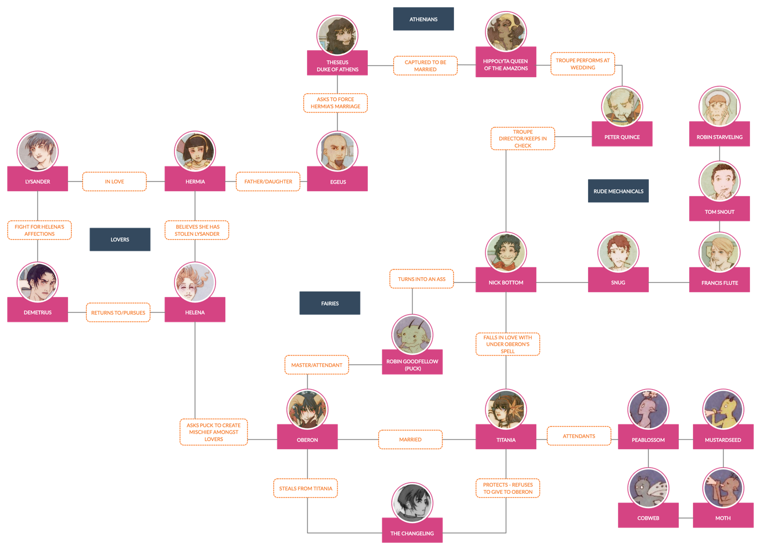

RELATIONSHIP MAP: VERSION 2

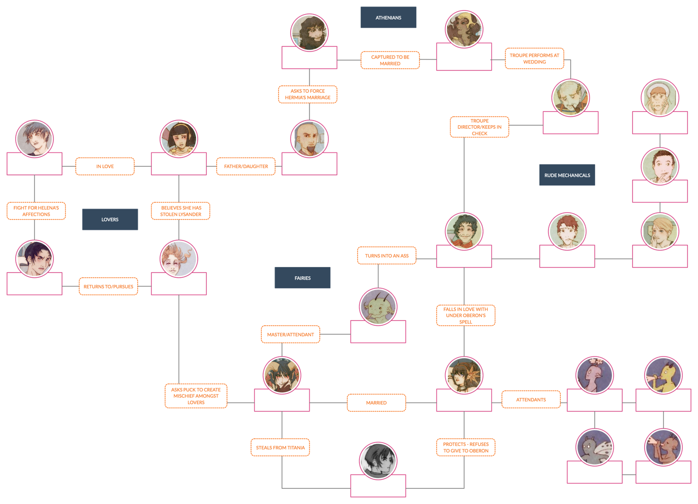

RELATIONSHIP MAP: VERSION 3

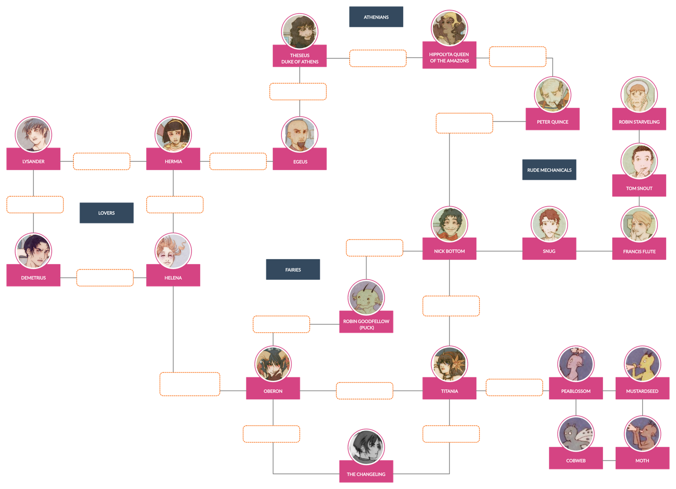

PLOT SUMMARY WORKSHEET

ACT 1

1) Before the play begins, we learn that Theseus, Duke of Athens, has conquered a race of people and taken their queen for his bride-to-be. What race of people did he conquer and what is the name of their queen?

2) Egeus is unhappy that his daughter is refusing to marry the man he has chosen for her, and complains to Duke Theseus. Theseus tells Hermia that if she refuses to obey her father, she has two choices. What are they?

Choice 1:
Choice 2:
3) Finish this sentence: Lysander and Hermia speak to each other in:

4) Why does Helena tell Demetrius of Hermia and Lysander’s secret plan?

ACT 2

1) Why are the fairy king and queen (Oberon and Titania) arguing?

2) How does the audience/reader know what time of day it is?

3) What does Oberon plan to do to Titania?

4) How does Oberon tell Puck he will recognise the ‘disdainful youth’?

5) Whom does Robin Goodfellow (Puck) mistake Hermia and Lysander for? And what chaos does the mistake cause?

ACT 3

1) What three problems are there with the play according to Bottom?

2) In what way was Bottom transformed?

3) Who is awakened by Bottom’s singing and instantly falls in love with him?

4) What does Hermia think Demetrius has done to Lysander?

5) Oberon realises Robin (Puck) has charmed the wrong man and made the situation worse. What does he order Robin to do?

6) Before everything can be sorted out with the lovers, both men are charmed with the flower and fall in love with Helena. How does Oberon instruct Robin to fix things?

ACT 4

1) Why does Oberon decide to release Titania from the enchantment?

2) What other enchantment is undone at this point in the story?

3) Which characters enter the scene after Oberon, Titania and the fairy attendants exit?

4) Who discovers the sleeping lovers?

5) What happens when the lovers are asked why all four are sleeping gently together when the two men are love rivals?

6) Which character is last to leave the woods?

7) What does Bottom tell his fellow actors to avoid eating?

ACT 5

1) Where does Act 5 take place?

2) Who delivers the prologue to the play?

3) What does Theseus ask the ‘Rude Mechanicals’ to do instead of delivering an epilogue?

4) Who arrives to bless the palace?

5) The last words of the play are spoken by which character?

QUIZ QUESTIONS

- Which character delivers a speech about lovers and madmen?

- Name two other Shakespeare plays which are referred to and can be used to make comparisons to characters and situations found within A Midsummer Night’s Dream?

- Name three texts which influenced Shakespeare when he was writing A Midsummer Night’s Dream.

- Egeus wants his daughter, Hermia, to marry , but she wants to marry .

- Who says, “And though she be but little, she is fierce” (Act 3, Scene 2).

- Name the characters who make up the group of ‘Rude Mechanicals’, and list their occupation and the role they play in ‘Pyramus and Thisbe’ next to their name.

- Who was the Changeling/Indian boy’s mother?

- Robin Goodfellow is a servant to Oberon. What other names is Robin known by?

- Who says: “Trip away, make no stay/Meet me all by break of day”?

- Which other Shakespeare play is entirely framed as a dream in which the character’s fantasies and desires are enacted? Name the character whose dream it is.

QUIZ QUESTIONS – MULTIPLE CHOICE:

- Which character delivers a speech about lovers and madmen?

- Egeus
- Demetrius
- Theseus
- Oberon

- Which two Shakespeare plays which are referred to and can be used to make comparisons to characters and situations found within A Midsummer Night’s Dream?

- As You Like It
- The Tempest
- Much Ado About Nothing
- The Merchant of Venice
- Romeo and Juliet

- Othello
- The Comedy of Errors
- Twelfth Night
- The Taming of the Shrew
- All’s Well that Ends Well
- Which three texts influenced Shakespeare when he was writing A Midsummer Night’s Dream?

- Plutarch’s Lives of the Most Noble Grecians and Romans
- The Essays of Michel de Montaigne, translated by John Florio
- Aristotle’s Poetics
- Ovid’s Metamorphoses
- Chaucer’s The Knight’s Tale
- Virgil’s Aeneid

- Egeus wants his daughter, Hermia, to marry ___________, but she wants to marry ____________.

- Lysander, Demetrius
- Theseus, Lysander
- Demetrius, Theseus
- Demetrius, Lysander

- Who says, “And though she be but little, she is fierce” (Act 3, Scene 2).

- Lysander
- Helena
- Hermia
- Demetrius

- Fill in the blanks for the members of the ‘Rude Mechanicals’, their names, occupation and the role they play in ‘Pyramus and Thisbe’.

Name | Occupation | Role
 | Weaver
Peter Quince |  | Presents the prologue
 |  | The Lion
Francis Flute | Bellows-mender
Tom Snout | Tinker
Robin Starveling |  | Moonshine

- Who was the Changeling/Indian boy’s mother?

- A vot’ress to Oberon
- A vot’ress to Hippolyta

- A vot’ress to Titania
- A vot’ress to Theseus
- Robin Goodfellow is a servant to Oberon. What other names is Robin known by? (Choose all that apply)

- Moth
- Puck
- Mustardseed
- Hobgoblin
- Goblin
- Peaseblossom

- Who says: “Trip away, make no stay/Meet me all by break of day”?

- Titania
- Robin Goodfellow
- Cobweb
- Oberon

- Which other Shakespeare play is entirely framed as a dream in which the character’s fantasies and desires are enacted? Name the character whose dream it is.

- The Merchant of Venice, Shylock
- The Taming of the Shrew, Christopher Sly
- Twelfth Night, Viola
- Much Ado About Nothing, Hero
- The Tempest, Caliban

SUGGESTED ASSIGNMENTS

Look at the speech from Act 5, Scene 1 in which Duke Theseus identifies “imagination” as a creative force that links “the lunatic, the lover and the poet”.

This speech brings together major themes which run through the play – metatheatre, dreams/transformation and illusion/reality. It emphasises the power of “imagination” to blur the boundaries between art and life, and to transform “things unknown” into new shapes – exactly the way magic functions in this play; it changes the way we see it.

ASSIGNMENT
Rewrite Theseus’ speech (see below) using prose and modern language, making it contemporary and relevant for a modern audience.

Lovers and madmen have such seething brains,
Such shaping fantasies, that apprehend
More than cool reason ever comprehends.
The lunatic, the lover, and the poet
Are of imagination all compact:
One sees more devils
than vast hell can hold;
That is the madman. The lover, all as frantic,
Sees Helen’s beauty in a brow of Egypt.
The poet’s eye, in a fine frenzy rolling,
Doth glance from heaven to earth, from earth to heaven;
And as imagination bodies forth
The forms of things unknown, the poet’s pen
Turns them to shapes, and gives to airy nothing
A local habitation and a name.

CHARACTERS & RELATIONSHIPS

The relationship between Duke Theseus and Hippolyta can be put into context by looking at Geoffrey Chaucer’s The Knight’s Tale, which was one of the sources that Shakespeare adapted and developed in this play.

ASSIGNMENT

Read Chaucer’s The Knight’s Tale (a version will need to be sourced by either the teacher or the student) and respond to the prompt below:

- Identify elements of Chaucer’s story that may have influenced Shakespeare’s writing. Provide specific examples from The Knight’s Tale and where you find that influence in A Midsummer Night’s Dream.

Extension Question
- Can you spot any other “borrowings” from this play? Share what you find and where you think the ideas were taken from. Provide specific examples and references where possible.

Hippolyta is not the only strong female in this play. There is another strong woman who poses a threat to male authority – Titania, the Fairy Queen. There are many parallels between the two couples and, in contrast to Theseus and Hippolyta, Oberon conquers Titania during the action of the play rather than before it begins.

ASSIGNMENT

Using the text of the play, respond to the following:

- Identify any other evidence in the play that suggests parallels between the Court at Athens and the Fairy Kingdom.
- How are the two couples similar and how are they different?

When we meet Oberon and Titania at the beginning of Act 2, both figures demonstrate signs of jealousy.

ASSIGNMENT

Using the text of the play, respond to the following:

- Examine the quarrel between Oberon and Titania in Act 2, Scene 1 and make a list of all the reasons for their argument. They seem to be debating who gets possession of the Changeling, but what other issues are lying under the surface?

- How is their jealousy shown to have an impact on the natural world?

In Romeo and Juliet, Juliet asks her lover not to swear by the “inconstant moon” which is always changing, unless his love proves just as liable to change.

ASSIGNMENT

Using the text of the play, respond to the following:

Create two lists of characters from A Midsummer Night’s Dream:
- Characters in the play whose affections are consistent
- Characters in the play whose affections change

- Do these groups divide evenly along gender lines?
- Women are often referred to as being ‘variable’ or ‘changeable’. Do you agree or disagree with this statement, and do you believe this play reinforces that idea? Explain your answer using supporting evidence from the text.

In Act 3, Scene 2, Robin Goodfellow (Puck) refers to the band of Athenian workmen who are putting on a play as the ‘Rude Mechanicals’.

ASSIGNMENT

Respond to the following:
- Why do you think that these two words spring to Robin’s mind at this point in the play?
- How do they reinforce your sense of Shakespeare’s characterisation of the Athenian workers?

A lot of the humour of the play-within-the-play arises from the gap between how the workmen, the ‘Rude Mechanicals’, see themselves, and how they are seen by their audience.

ASSIGNMENT

- Cite evidence in the text that demonstrates such a gap.
- Explain the effect of that gap.

Robin Goodfellow, also known as Puck, enjoys a special status among the fairies in that he serves Oberon.
ASSIGNMENT

Draw what you believe Robin Goodfellow looks like based on details and clues found in the text.

Look up an image of Henry Fuseli’s 1802 engraving of Puck:
- Describe the character you see in the image.
- Does it correspond with your own reading/drawing of the character? Share the similarities and differences.
- Cite evidence and specific examples from the text to support this interpretation.

THEMES

DISCORD/HARMONY

ASSIGNMENT

Respond to the following:

- To what extent is this play about creating harmony from disharmony, or concord from discord? Cite specific examples from the text to illustrate your argument.

WOMEN

Both Helena and Hermia barely speak in Act 5, yet Hippolyta is far from silent, despite her reluctance to speak in Act 1.

ASSIGNMENT

Explain and support your opinion on why you think Shakespeare chose to make Hippolyta so vocal in this last act, in contrast to her silence in Act 1, and in contrast to the silence of Helena/Hermia. Make sure to include how we might read Hippolyta’s dialogue in this act compared to the silence of the other women.

DREAMS/TRANSFORMATION

Marjorie B Garber suggests that dreams become “truer than the reality they seek to interpret and transform” in this play, suggesting that imagination and transformation are more important than rational thought (embodied by Theseus). Journeying into the woods and engaging in the transformations that occur literally makes the characters see differently (and perhaps more clearly) as a result.

ASSIGNMENT

Respond to the following questions:

- Look at the character of Bottom and think about what his transformation reveals, if anything, about reality.
- Does the ass-head symbolise Bottom’s true nature? Give evidence to support your argument.

TRANSFORMATION

ASSIGNMENT
Respond to the following:

- In what ways do you think the experiences of transformation in this play reveal the ways in which characters experience and understand themselves? Use evidence from the play to support your arguments.

Ovid’s Metamorphoses is a book all about transformation. Spend some time investigating some of the myths Ovid narrates in Metamorphoses (such as Apollo and Daphne) and respond to the following:

- In what ways do the myths intersect with the themes and concerns of A Midsummer Night’s Dream? How do you think they may have influenced Shakespeare’s imagination?

- How would they influence your overall concept for the play if you were directing or designing it? Share specific details using evidence from the text of A Midsummer Night’s Dream and the myths from Metamorphoses.

LANGUAGE

BLANK VERSE

Blank verse refers to dialogue that doesn’t rhyme and is written in iambic pentameter. A Midsummer Night’s Dream begins with a lot of blank verse – it’s the dominant form in Athens, and the style in which civilised courtiers such as Egeus speak.

Blank verse is, however, also used by Oberon and Titania during their quarrel in Act 2, Scene 1. The first dialogue that we hear spoken by the rulers of the fairy kingdom sounds very similar to that spoken by the rulers of Athens, Theseus and Hippolyta, in Act 1, Scene 1.

ASSIGNMENT

Respond to the following questions and support your answers using specific examples from the text:

- Why do you think the play makes a connection between both of these couples by having them speak in blank verse?
- What is the effect of having the king and queen of the fairies speak like humans in Act 2, Scene 1?

PROSE & LANGUAGE GOING WRONG

Our introduction to the ‘Rude Mechanicals’ confronts us with a language wholly different in its rhythms, sound and texture. Because they speak in prose rather than in verse, their social class as working men is soon established.

ASSIGNMENT

Look at Peter Quince’s prologue to the Rude Mechanicals’ performance of ‘Pyramus & Thisbe’, staged at Theseus’ court in Act 5, Scene 1, and complete the following:

- Walk through a space/around the room as you read the prologue aloud and change direction every time you hit a punctuation mark.
- Remove all punctuation and read the speech again. Does it begin to make more sense?
- Rewrite the prologue by changing the punctuation to make it clearer.

If we offend, it is with our good will.
That you should think, we come not to offend,
But with good will. To show our simple skill,
That is the true beginning of our end.
Consider then, we come but in despite.
We do not come as minding to content you,
Our true intent is. All for your delight,
We are not here. That you should here repent you,
The actors are at hand; and by their show
You shall know all that you
are like to know.

DRAMATURGY AND INTERPRETATION

Theseus describes winning and wooing Hippolyta using images that relate to war and violence, he intends to “wed” her “in another key”:
With pomp, with triumph, and with revelling (Act 1, Scene 1).
Many actors and directors have been interested in the ambiguity of these lines. Is Hippolyta being forced to marry against her will, and how does she react to Theseus’ intention to celebrate their union in positive terms?

John Hancock’s 1966 production in San Francisco decided to make this ambiguity decidedly non-ambiguous. In his version, Hippolyta was transported onto the stage in a cage as if she were an animal. She wore body make-up and a leopard-skin bikini in a bamboo cage and delivered her lines sarcastically.

ASSIGNMENT

Research other examples of how various actors and theatre directors have interpreted the relationship between Theseus and Hippolyta.

- Write down how they communicate their choices, for example, through the delivery of the language, through staging, costume and design choices etc.
- Which interpretations are best supported by the text, in your opinion, and why?
- How would you interpret this relationship and present it on stage? Explain your choices/concept and support it with evidence from the text.
- Create a drawing/model/visual representation which depicts the relationship between Theseus and Hippolyta.
- Compile the research together into an online notebook/online presentation.

INTERPRETATION

In Act 4, Scene 1, Theseus overrules Egeus’ will and allows Hermia to marry Lysander. After this moment, Egeus has no more lines.

In an earlier version of the play (the Quarto version), the Master of the Revels at Theseus and Hippolyta’s wedding is not Egeus but another character called Philostrate. This seems to have been altered during a revision of the text.
Even in productions that introduce a new character in Act 5 (Philostrate), Hermia’s father can still feature in this final scene. In John Caird’s 1989 production for the RSC, he included Egeus in Act 5, Scene 2 as a member of the court watching the entertainments. He was then persuaded to join the dance with Hermia and reconcile with his daughter, even though there is no dialogue to suggest this.

ASSIGNMENT

Respond to the following from a director’s point of view:

- What are the implications of Egeus reappearing here in the final scene?
- What would you do if you were directing this scene?
- What other choices are available in terms of how to stage these relationships in Act 5?
- Consider, for instance, that Helena and Hermia also have no lines now that they are married – how, then, should they react to events?

Peter Hall, in his 1969 film of the play, depicted the fairies as rough and muddy children, imagining them as playful and mischievous urchins covered in mud. Some scholars, however, have suggested the possibility of having the actors who play the ‘Rude Mechanicals’ (apart from Bottom) double as the fairies.

ASSIGNMENT

Respond to the following from a director’s point of view:

- What are the implications of these different choices?
- How would you cast the fairies if you were to stage the play, and why?
- Create a mood board/collage full of ideas and inspiration for your concept of the fairies.

GENRE

ASSIGNMENT

- To what extent could Act 1, Scene 1 be introduced as a tragedy rather than a comedy?
- Rewrite the scene as if the play were a tragedy.
- Create an outline/overview of each act and scene of the play, reimagining it as a tragedy.
- How would your designs be affected/altered/changed if this play was a tragedy instead of a comedy?

PLOT SUMMARY WORKSHEET – ANSWERS

ACT 1

1) Before the play begins, we learn that Theseus, Duke of Athens, has conquered a race of people and taken their queen for his bride-to-be. What race of people did he conquer and what is the name of their queen?

Amazons, Hippolyta

2) Egeus is unhappy that his daughter is refusing to marry the man he has chosen for her, and complains to Duke Theseus. Theseus tells Hermia that if she refuses to obey her father, she has two choices. What are they?

1) To die
2) ‘Abjure forever the society of men’ (become a nun)

3) Finish this sentence: Lysander and Hermia speak to each other in:
Rhyming couplets.

4) Why does Helena tell Demetrius of Hermia and Lysander’s secret plan?

So she can see him and receive his thanks

ACT 2

1) Why are the fairy king and queen (Oberon and Titania) arguing?

Because Titania has ‘a lovely boy stol’n from an Indian king’

2) How does the audience/reader know what time of day it is?

Oberon exclaims ‘ill met by moonlight, proud Titania’ which reveals it is night-time.

3) What does Oberon plan to do to Titania?

He plans to use the juice of a flower called ‘love-in-idleness’ to charm her and make her fall in love with an animal, and to snatch the Changeling while she is charmed and thus distracted.

4) How does Oberon tell Puck he will recognise the ‘disdainful youth’?

He is recognisable because of his Athenian clothes

5) Whom does Robin Goodfellow (Puck) mistake Hermia and Lysander for? And what chaos does the mistake cause?

Helena & Demetrius
Lysander is now in love with Helena and not Hermia
ACT 3

1) What three problems are there with the play according to Bottom?

- Ladies in the audience may find it difficult to handle Pyramus’ suicide
- The lion may be too fearsome for the ladies
- How to create the effect of moonshine

2) In what way was Bottom transformed?

Robin (Puck) gave him the head of an ass

3) Who is awakened by Bottom’s singing and instantly falls in love with him?

Titania

4) What does Hermia think Demetrius has done to Lysander?

She thinks he may have killed him and hidden the body

5) Oberon realises Robin (Puck) has charmed the wrong man and made the situation worse. What does he order Robin to do?

He orders Robin to go and find Helena and bring her here so Demetrius can be charmed with the flower.

6) Before everything can be sorted out with the lovers, both men are charmed with the flower and fall in love with Helena. How does Oberon instruct Robin to fix things?

Oberon tells him to descend a fog over the wood so that the lovers, so keen on fighting, cannot find each other. Robin will impersonate the voices of Lysander and Demetrius in the fog and lead them all over the wood until they are exhausted, only to repeat the flower trick while they sleep.

ACT 4

1) Why does Oberon decide to release Titania from the enchantment?

He achieved his goal of getting the Indian/Changeling boy away from her

2) What other enchantment is undone at this point in the story?

Robin removes the ass’ head from Bottom

3) Which characters enter the scene after Oberon, Titania and the fairy attendants exit?

Theseus, Hippolyta, Egeus, and all of their attendants

4) Who discovers the sleeping lovers?

Egeus

5) What happens when the lovers are asked why all four are sleeping gently together when the two men are love rivals?

Lysander says all he remembers is coming to the wood with Hermia to flee Athenian law. Demetrius interrupts to say he remembers coming to the wood because Helena warned him of the secret marriage, but reveals he no longer loves Hermia and the one he truly loves is Helena.
6) Which character is last to leave the woods?

Bottom

7) What does Bottom tell his fellow actors to avoid eating?

Onions or garlic

ACT 5

1) Where does Act 5 take place?

In Athens, in the grounds of Theseus’ palace

2) Who delivers the prologue to the play?

Peter Quince

3) What does Theseus ask the ‘Rude Mechanicals’ to do instead of delivering an epilogue?

He asks them to dance

4) Who arrives to bless the palace?

Oberon, Titania, and their attendants

5) The last words of the play are spoken by which character?

Robin Goodfellow (Puck)
QUIZ QUESTIONS – ANSWERS

- Which character delivers a speech about lovers and madmen?

Answer: Theseus

- Name two other Shakespeare plays which are referred to and can be used to make comparisons to characters and situations found within A Midsummer Night’s Dream?

Answer: Romeo and Juliet, Othello, The Tempest, The Taming of the Shrew
- Name three texts which influenced Shakespeare when he was writing A Midsummer Night’s Dream.

Answer: Chaucer’s The Knight’s Tale, Ovid’s Metamorphoses, Thomas North’s translation of Plutarch’s Life of Theseus taken from the Lives of the Noble Grecians and Romans.

- Egeus wants his daughter, Hermia, to marry Demetrius, but she wants to marry Lysander.

- Who says, “And though she be but little, she is fierce” (Act 3, Scene 2). Answer: Helena

- Name the characters who make up the group of ‘Rude Mechanicals’, and list their occupation and the role they play in Pyramus and Thisbe next to their name.

Answer:

Name | Occupation | Role
Nick Bottom | Weaver | Pyramus
Peter Quince | Carpenter | Presents the prologue
Snug | Joiner | The Lion
Francis Flute | Bellows-mender | Thisbe
Tom Snout | Tinker | The Wall
Robin Starveling | Tailor | Moonshine

- Who was the Changeling/Indian boy’s mother?

Answer: She was a mortal woman who was Titania’s vot’ress

- Robin Goodfellow is a servant to Oberon. What other names is Robin known by?

Answer: Puck, Hobgoblin

- Who says: “Trip away, make no stay/Meet me all by break of day”?

Answer: Oberon

- Which other Shakespeare play is entirely framed as a dream in which the character’s fantasies and desires are enacted? Name the character whose dream it is.

Answer: Christopher Sly from The Taming of the Shrew

