ACTIVATE GREEK THEATRE:

Antigone

The Digital Theatre+ Activate series provides teachers with a variety of ready-made materials including quizzes, relationship maps and plot summary worksheets for teaching a specific text. This guide will help you save time creating engaging and relevant activities for your students.

Content and activities in this pack have been extracted and adapted from our Antigone Study Guide written by Ed Madden. The study guide can be used as a source for revision and additional information as you use these activities in your classroom.

In this guide you will find:

Relationship Maps
- Version 1
- Version 2
- Version 3

Plot Summary Worksheet
- Plot summary worksheet with answers

Quiz Questions
- Quiz questions with answers
- Quiz questions – multiple choice
- Quiz questions – multiple choice with answers

Suggested Assignments
- Characters & Relationships
- Themes
- Language
- Context

RELATIONSHIP MAPS
Our relationship maps provide you and your students with a visual representation of how the characters in the play are all connected. These can be given to your students to help further understand character relationships while reading the text or can be used as a revision tool and for assessments.

On the following pages, you’ll find three versions of the relationship map:

Version 1: Relationship map showing character names and relationships
Version 2: Relationship map without character names
Version 3: Relationship map without relationship descriptions.

All images for our relationship maps have been taken from BBC Studios’ production of Antigone.

RELATIONSHIP MAP: VERSION 1

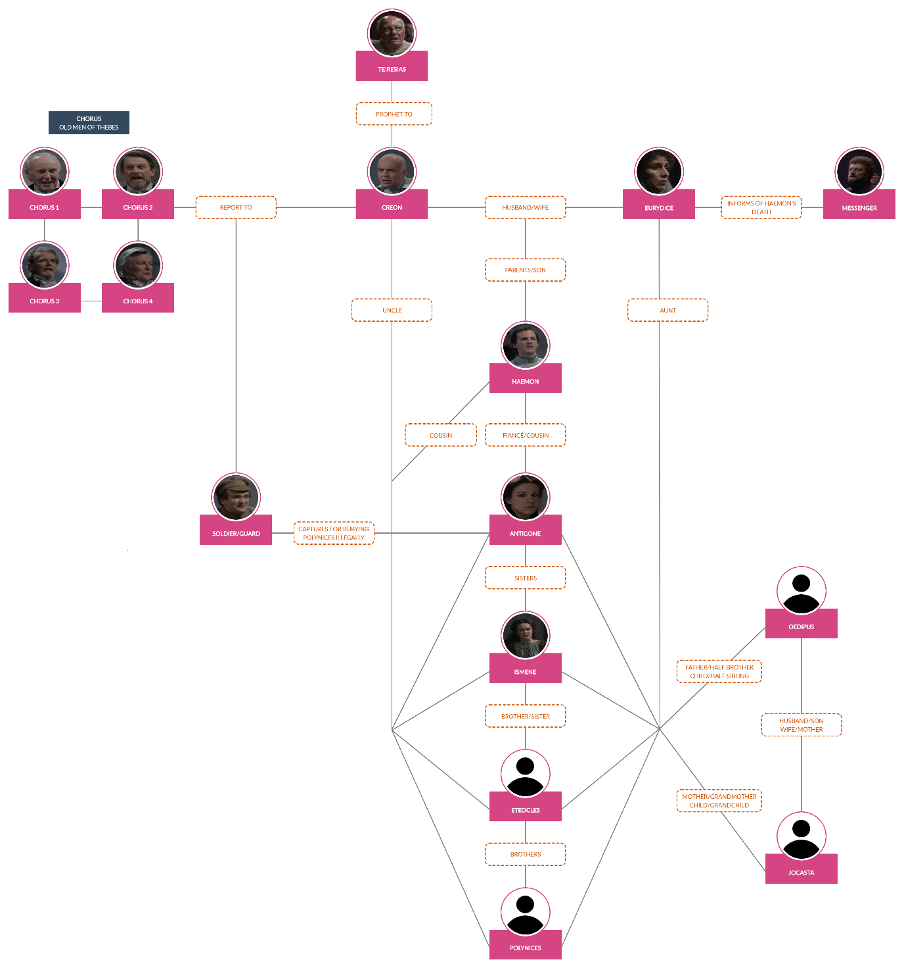

RELATIONSHIP MAP: VERSION 2

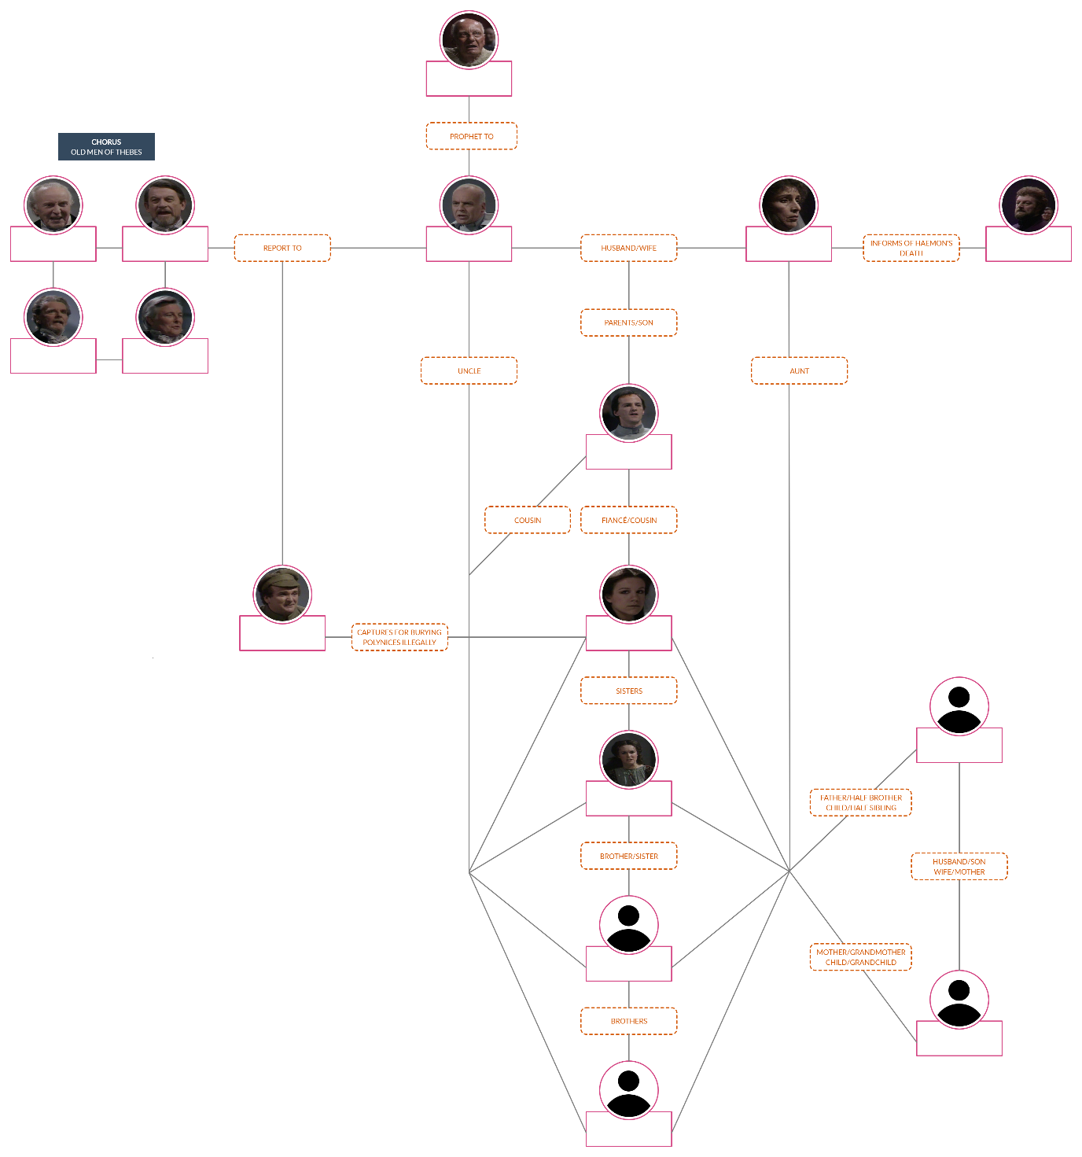

RELATIONSHIP MAP: VERSION 3

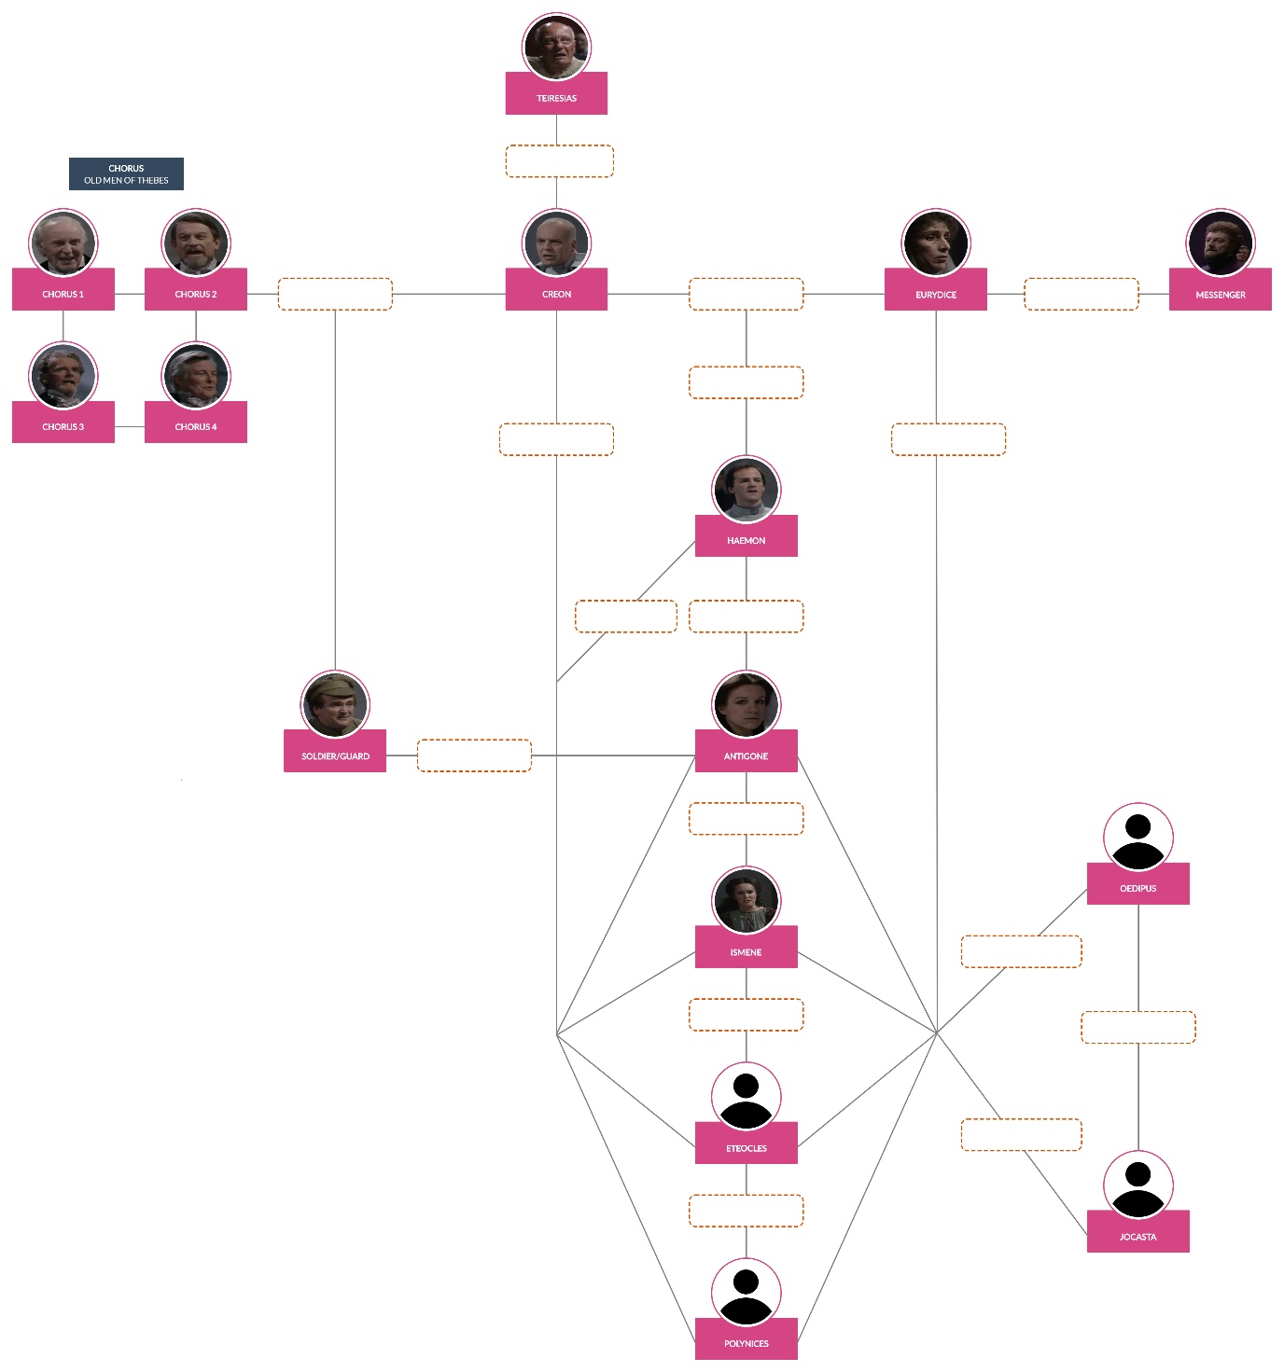

PLOT SUMMARY WORKSHEET

PROLOGUE

1) Before the play begins, what major event has just occurred in Thebes?

2) What royal proclamation is the inciting incident that sets events in motion in the play? Who makes it?

3) What decision does Antigone make about Polynices at the beginning of the play?

4) Ismene warns Antigone about avoiding the cycle of violence in their family history. To what family history is Ismene referring?

PARADOS

5) When we first meet the Chorus, why are they celebrating?

EPISODE

6) In his first speech, who does Creon ask the Chorus to display no sympathy for?

7) When a guard arrives after Creon’s first speech, what does the guard tell Creon?

8) How do Creon’s and the Chorus’ reactions to the guard’s news differ?

CHORAL ODE

9) Why is the second chorus called “Ode to Man”?

EPISODE

10) What two things do the guards catch Antigone doing?

11) When the guard brings Antigone to Creon, why do Antigone and Creon argue?

12) What are the main points that Antigone and Creon make when they argue?

13) When Ismene enters after Antigone and Creon argue, what does she try to convince Creon of? Is she successful?

14) After they argue, what does Creon decide about Antigone?

CHORAL ODE

15) What does the third chorus say about sorrow and how does this relate to the history of the House of Oedipus?

EPISODE

16) What happens when Haemon tries to talk to Creon?
First, Haemon

Then, Creon

Finally, Haemon

CHORAL ODE

17) In the fourth chorus, what does Creon tell the Chorus he plans to do with Antigone?

18) In the fourth chorus, what does the Chorus say to Antigone?

EPISODE

19) In her final speech before she’s taken away, what does Antigone argue?

CHORAL ODE

20) The fifth chorus contains a list of Greek figures. How are they all similar to Danae?

EPISODE

21) What does Teiresias advise Creon about Polynices and Antigone?
Advice about Polynices:

Advice about Creon:

22) What two things does the Chorus tell Creon to do after Teiresias leaves?

23) What does Creon decide to do after listening to the Chorus?

24) What happens to Antigone?

25) What happens when Haemon faces Creon after seeing Antigone?

26) What does Eurydice do when she hears the messenger’s news?

27) At the end of the play, how does Creon react to the results of the decisions he has made?

EXODUS

28) What is the Chorus’ final message about pride?

QUIZ QUESTIONS
- Which two members of the royal family fought on opposing sides in the Theban Civil War?

- One of the main conflicts of the play is between the rule of the gods and the laws of .

- Which character provides comic relief?

- Which group of people does the Chorus represent?

- The guard says he has “won the privilege of bringing the good news.” Why is this statement ironic?

- What is the purpose of the messenger’s speech “Rejoice in great wealth all you like and live in a palace, but if there is no happiness in your life then all is worthless smoke and shadow”?

- Who says, “I just can’t break the laws of the city”?

- Why is Antigone important to Haemon?

- In what city does the play take place?

- What does Creon say to motivate the guard to find out who buried Polynices?

- Who says, “Why should I try to soothe you with kind words which will later make me a liar?”

- The Chorus comments on the power of love and passion, noting that “all who are passion’s slaves are .”
- Who is Teiresias?

- The fifth chorus references Bacchus/Dionysus. Name two things Bacchus/Dionysus was the god of.

- Just before her death, Eurydice blames Creon for the deaths of and .

- In its final message, the Chorus says that true happiness must come from .

- Name two things that the character of Antigone symbolises.

- In defying Creon, Antigone also defies society’s expectations of .

- Ismene provides a contrast to her sister, , because Ismene believes women are .

- How does the guard’s language identify him as a regular person rather than royalty?

QUIZ QUESTIONS – MULTIPLE CHOICE

- Which members of the royal family fought on opposing sides in the Theban Civil War? Choose two answers.

- Creon d) Ismene
- Eteocles e) Eurydice
- Antigone f) Polynices

- One of the main conflicts of the play is between the rule of the gods and the laws of .

- Man c) Thebes
- Kings d) Greece

- Which character provides comic relief?

- Teiresias c) The messenger
- Haemon d) The guard

- Which group of people does the Chorus represent?

- Newly arrived citizens c) Commoners
- Well-respected elders d) Businessmen

- The guard says he has “won the privilege of bringing the good news.” This statement is ironic because it’s .

- Angry c) Sarcastic
- True d) Honest

- What is the purpose of the messenger’s speech “Rejoice in great wealth all you like and live in a palace, but if there is no happiness in your life then all is worthless smoke and shadow”?

- It explains the messenger’s motivation.
- It explains the messenger’s actions.
- It describes the setting of the play.
- It gives the moral of the play.

- Who says, “I just can’t break the laws of the city”?

- Antigone c) Ismene
- The guard d) The messenger

- Antigone is important to Haemon because she’s his .

- Fiancé c) Wife
- Sister d) Mother

- In what city does the play take place?

- Troy c) Thebes
- Athens d) Antigonia

- To motivate the guard to find out who buried Polynices, Creon threatens him with .

- Death c) Exile
- Jail d) Torture

- Who says, “Why should I try to soothe you with kind words which will later make me a liar?”

- The Guard c) Teiresias
- Creon d) The Messenger

- The Chorus comments on the power of love and passion, noting that “all who are passion’s slaves are .”

- Fortunate c) Courageous
- Mad d) Strong

- Who is Teiresias?

- A travelling salesman
- A member of the royal family
- A blind prophet
- A part of the royal guard

- The fifth chorus references Bacchus/Dionysus. Which are two of the things was Bacchus/Dionysus the god of?

- Theatre d) The hunt
- Love e) Beauty
- The sun f) Dance

- Just before her death, Eurydice blames Creon for the deaths of
and .

- Eteocles, Polynices c) Antigone, Ismene
- Haemon, herself d) Oedipus, Jocasta

- In its final message, the Chorus says that true happiness must come from .

- Good sense c) Wise decisions
- Family loyalty d) Strong morals

- Which three things does the character of Antigone symbolise?

- Feminine revolt d) Daughterly responsibility
- Political rebellion e) Royal rule
- Romantic loyalty f) Moral duty

- In defying Creon, Antigone also defies society’s expectations of
.

- Royalty c) Religion
- Sisters d) Women

- Ismene provides a contrast to her sister, , because Ismene believes women are .

- Antigone, helpless c) Eurydice, brave
- Antigone, weak d) Eurydice, cunning

- The guard’s language identifies him as a regular person rather than royalty because his language is .

- Complicated and formal c) Descriptive and fancy
- Informal and colloquial d) Simple and short

SUGGESTED ASSIGNMENTS

CHARACTERS & RELATIONSHIPS

Antigone is often viewed as a hero for the way she stands up for what she believes is her moral and religious duty.

ASSIGNMENT
Using the text of the play, respond to the following:
- Can we view Antigone as a tragic hero? Is “hero” the right word?

EXTENSION QUESTION
- Some argue that “Antigone is a religious fundamentalist, not a hero.” Do you agree or disagree? Using details from the play, explain why.

We gain insight into Antigone’s character and motivations through her actions and interactions with other characters in the play.

ASSIGNMENT
Using the text of the play, respond to the following:
- How does Antigone's relationship with her sister inform our understanding of her character?
- What is the significance of Antigone hanging herself rather than dying due to lack of food and water?

EXTENSION QUESTION
- As a result of Antigone's decision to bury her brother, three people (including Antigone herself) are dead by the end of the play. Is she selfish? Use examples from the play to explain why, or why not.

Creon is not a simple villain acting to further his own evil ends; he believes that what he is doing is right, and it is the best way to ensure the security and prosperity of Thebes.

ASSIGNMENT
Using the text of the play, respond to the following:
- "Creon's biggest issue isn't with lawbreakers, but with women." Use details from the play to prove or disprove this statement.
- Explain why or why not Creon should be viewed as a tragic hero.
- An actor playing Creon probably has the largest emotional journey of any in the play; unlike Antigone, he is very different at the end of the play from how he is at the beginning. What directorial instruction would you give an actor playing the role?

EXTENSION QUESTION
- Try to rewrite the timeline of the play so that Creon makes the "correct" decisions along the way. Then explain your experience: how easy or difficult was it to change his decisions? What other problems might your changes have caused him?

The biggest difference between Ismene and Antigone is that while they both disagree with Creon's law and believe that the law of the gods says that Polynices should be buried, lsmene simply can’t bring herself to defy Creon.

ASSIGNMENT
Using the text of the play, respond to the following:
- Do you think that “the greatest tragedy of the play is the tragedy of lsmene”? Why? Support your opinion with specific examples from the text.
- Why does lsmene lie to Creon and say that she helped Antigone bury the body of Polynices?
- Think of three different ways an actor could choose to play the role of lsmene in the first scene. How would each of these interpretations affect the audience's opinion of the character?

Haemon’s position is complicated because he is engaged to Antigone, but also loyal to his father, Creon. Haemon understands how stubborn and easily angered his father is and attempts to win him over with as little conflict as possible.

ASSIGNMENT
Using the text of the play, respond to the following:
- "There is nothing I want more, father, than your wellbeing.” Do you believe Haemon when he says this, or do you think it’s simply a persuasive tactic? Why? Support your opinion with specific examples from the text.
- Why do you think Haemon kills himself? Why do you think when his attempt to attack his father fails, that he doesn't try again?

Though Eurydice is the queen and Haemon’s mother, she only appears briefly in the play and speaks very little.

ASSIGNMENT
Using the text of the play, respond to the following:
- What effect does Eurydice's silence have? How would her role in the play be different if she had, for example, a long monologue blaming Creon for her son's death?
- Imagine you are a director. How would you ask the actor playing Eurydice to perform the role?

Although the Chorus has a unique relationship with the audience, it is still subject to the king and, therefore, does not exist above the action of the play.

ASSIGNMENT
Using the text of the play, respond to the following:
- Why do you think that critics say that “the choral odes are what turn Antigone from a good play into a great play”? Do you agree? Support your opinion with specific examples from the text.

THEMES

INDIVIDUAL VS. STATE / CONSCIENCE VS. LAW
In Antigone, Sophocles asks the audience to consider whether it is ever right to break the law. Rather than give a simple answer, he makes valid arguments for both Antigone’s and Creon’s points of view.

ASSIGNMENT
Respond to the following:
- How is language used to constitute authority in Antigone?
- "In Greek tragedies, questions of right and wrong are always answered by the Chorus." How does this statement apply to Antigone?

EXTENSION QUESTION
- Do you agree with Antigone or with Creon? Go with your gut instinct. Now think about the point of view of the character you did not choose and write an essay explaining why their position is right. Support your opinion with specific examples from the text.

GENDER AND FEMINITY
In these three women, Antigone, Eurydice, and Ismene - one who is killed, one who kills herself, and one who lives to continue a life of oppression – Sophocles gives us a scathing critique of the treatment of women in Ancient Greek society.

ASSIGNMENT
- How differently are women treated today from how they were treated in Ancient Greece? In what ways might Sophocles' critique of the treatment of women resonate with contemporary audiences? Cite specific examples from the text.
- "lsmene is no better than Creon; if we are to criticise his actions then we must criticise her inaction." Use details from the text to explain why you agree or disagree with this statement.

FATE AND FREE WILL
Antigone is punished for a single, wilfully rebellious action; at first glance her decision to bury Polynices seems like a decision entirely of free will. Later in the play, however, there is a suggestion that Antigone was fated for tragedy.

ASSIGNMENT
Respond to the following:
- Imagine you are directing a production of Antigone. What choices would you make if you have decided that the events of the play occur at the will of the gods? How would these choices be different if you decide that it is the characters' choices that influence what happens to them?

The Chorus suggests that Antigone’s fate has already been decided and her life will end in tragedy. But the Chorus also suggests that people are capable of being masters of their own fate.

ASSIGNMENT
Respond to the following:
- In Anoulih's Antigone, the chorus proclaims at the opening: "in short, when your name is Antigone, there is only one part you can play, and she must play hers through to the end." Do you agree that Antigone has no free will? Why or why not? Support your opinion with specific examples from the text.

EXTENSION QUESTION
- "Every character in Antigone fulfils their fate. The play is over from the beginning." Using details from the play, explain why this statement is true or false.

LANGUAGE

LANGUAGE AND AUTHORITY
Every character in the play uses language to state their case in a different way and identifying why each of them speaks in the way they do is a great way of understanding how Sophocles’ mind works as a writer.

ASSIGNMENT
Respond to the following:
- How does Sophocles use religious language and imagery in the play? What effect does this have? Cite specific examples from the text.

THE CHORAL ODES
The choral odes use the most heightened language in Antigone.

ASSIGNMENT
Respond to the following:
- Think about where the choral odes come in the play. What is the significance of their position in the structure of the play? How might the change in the tone of the language at these moments affect the audience?

EXTENSION QUESTION
- Write a paragraph in standard English about how much you love something: your favourite TV show, a sports team you support, your family, etc. Now turn your paragraph into an ‘ode’ in the style of the Chorus in Antigone. Then follow your ‘ode’ with an analysis. What feels different about the ‘ode’ version? How is the sentiment of the writing changed by the different language styles?

CONTEXT

GREEK THEATRE
In Ancient Greek society, going to the theatre was an act of religious worship rather than simple entertainment. The Greeks used theatre to worship Dionysus, god of theatre, music, and dance, among other things. Theatre was an important part of society. Every adult male attended as an act of religious duty. All roles were performed by masked male actors, each of which played multiple roles.

ASSIGNMENT
Respond to the following:
- Find three references in the play either to Dionysus or other Greek gods. How does the meaning of these references change now that you know the cultural context in which the play was written?
- In what ways is Antigone “a play about all of society, and for all of society”? Cite specific examples from the text.
- If you had to choose a play for everyone in the country today to go and see, which play would you choose? Why?
- Antigone would have first been performed with three actors. Can you work out how the roles would have been divided based on which characters appear onstage together? How might actors playing multiple roles have informed audiences' experience of the play?

THE THEBAN PLAYS
Oedipus and his family are referenced several times in Antigone. During his reign as King of Thebes, Oedipus discovers the details of his past, resulting in great tragedy and, ultimately, his exile.

ASSIGNMENT
Respond to the following:
- Greek audiences would have known the story of Oedipus before seeing Antigone. What effect might this knowledge have had on their experience of the play?
- Find some of the references the Chorus make to Oedipus. What is their purpose? Support your opinion with specific details.

ANTIGONE THROUGH TIME
Given its themes of rebellion and protest, Antigone has been performed in many different contexts in response to various political situations.

ASSIGNMENT
- Imagine you are staging a production of Antigone now. How might it respond to current events?

EXTENSION QUESTION
- Where and how would you stage a modern version of Antigone to emphasise its relationship to current events?

PLOT SUMMARY WORKSHEET – ANSWERS

PROLOGUE

1) Before the play begins, what major event has just occurred in Thebes?
The Theban Civil War

2) What royal proclamation is the inciting incident that sets events in motion in the play? Who makes it?
Creon decrees that his nephew Polynices must not be buried and that anyone who attempts to bury Polynices will be stoned to death.

3) What decision does Antigone make about Polynices at the beginning of the play?
She decides to defy Creon’s decree and bury Polynices.

4) Ismene warns Antigone about avoiding the cycle of violence in their family history. To what family history is Ismene referring?
Ismene is referring to the fact that they are Oedipus’ daughters, and Oedipus unwittingly killed his father and married his mother. As a result, Oedipus blinded himself and died in exile.

PARADOS

5) When we first meet the Chorus, why are they celebrating?
They are celebrating Eteocles’ victory over Polynices and are welcoming Creon as their new leader.

EPISODE

6) In his first speech, who does Creon ask the Chorus to display no sympathy for?
Lawbreakers

7) When a guard arrives after Creon’s first speech, what does the guard tell Creon?
The guard tells Creon that someone has scattered earth over Polynices’ body and performed burial rites.

8) How do Creon’s and the Chorus’ reactions to the guard’s news differ?
The Chorus wonders if the gods are responsible, but Creon is enraged and insists that the gods wouldn’t honour a traitor.

CHORAL ODE

9) Why is the second chorus called “Ode to Man”?
Because it lists accomplishments that humans have made.

EPISODE

10) What two things do the guards catch Antigone doing?
  - Re-covering Polynices’ body with earth.
  - Pouring a sacred offering of milk, honey, and water.

11) When the guard brings Antigone to Creon, why do Antigone and Creon argue?
Antigone confesses that she buried Polynices. She and Creon argue over whether she has the right to defy him and bury Polynices.

12) What are the main points that Antigone and Creon make when they argue?
Antigone believes that the rule of the gods is more important than anything a king says and, therefore, Polynices deserves a burial. In contrast, Creon doesn’t believe that traitors have the same rights as heroes, and therefore, Polynices shouldn’t be buried. He also resents being contradicted by a woman.

13) When Ismene enters after Antigone and Creon argue, what does she try to convince Creon of? Is she successful?
Ismene tries to convince Creon that she helped Antigone bury Polynices. However, she is not successful because Antigone tells Creon she alone committed the crime.

14) After they argue, what does Creon decide about Antigone?
Creon sentences Antigone to death.

CHORAL ODE

15) What does the third chorus say about sorrow and how does this relate to the history of the House of Oedipus?
The third chorus says sorrow is passed down through generations, which is a reference to how Antigone’s impending death is just the latest in a long line of tragedies for the House of Oedipus.

EPISODE

16) What happens when Haemon tries to talk to Creon?
First, Haemon tries to warn his father, Creon, that there is some public sympathy for Antigone.
Then, Creon doesn’t see that his son is trying to help him and instead is stubborn and angry, insisting that his son has been poisoned by Antigone.
Finally, Haemon leaves, vowing to never see his father again.

CHORAL ODE

17) In the fourth chorus, what does Creon tell the Chorus he plans to do with Antigone?
He plans to kill her by sealing her up in tomb with a small amount of food and drink, away from the city, so her death doesn’t pollute Thebes.

18) In the fourth chorus, what does the Chorus say to Antigone?
The Chorus says that although they respect her reverence for her brother, they also feel that she has added to the crimes of the House of Oedipus by choosing to defy Creon’s decree.

EPISODE

19) In her final speech before she’s taken away, what does Antigone argue?
She argues the case for burying Polynices, insisting he deserves to be honoured.

CHORAL ODE

20) The fifth chorus contains a list of Greek figures. How are they all similar to Danae?
They were imprisoned the same way Antigone is about to be.

EPISODE

21) What does Teiresias advise Creon about Polynices and Antigone?
Advice about Polynices: Teiresias warns Creon that his decision not to allow Polynices’ burial was a mistake.
Advice about Creon: Teiresias warns Creon that sentencing Antigone to death has upset the gods and will result in the death of one of Creon’s children.

22) What two things does the Chorus tell Creon to do after Teiresias leaves?
  - Release Antigone.
  - Build a proper tomb for Polynices.

23) What does Creon decide to do after listening to the Chorus?
He decides to bury Polynices.

24) What happens to Antigone?
She hangs herself.
25) What happens when Haemon faces Creon after seeing Antigone?
Haemon tries to stab Creon, then kills himself.

26) What does Eurydice do when she hears the messenger’s news?
She leaves without a word and then kills herself.

27) At the end of the play, how does Creon react to the results of the decisions he has made?
He accepts responsibility and feels grief and despair.

EXODUS

28) What is the Chorus’ final message about pride?
Pride will always be punished by the gods.

QUIZ QUESTIONS – ANSWERS
- Which two members of the royal family fought on opposing sides in the Theban Civil War?
Answer: Polynices and Eteocles

- One of the main conflicts of the play is between the rule of the gods and the laws of man.

- Which character provides comic relief?
Answer: The guard

- Which group of people does the Chorus represent?
Answer: Well-respected elders

- The guard says he has “won the privilege of bringing the good news.” Why is this statement ironic?
Answer: It’s ironic because he’s being sarcastic. He’s actually afraid of how Creon will react to the bad news he’s bringing.

- What is the purpose of the messenger’s speech “Rejoice in great wealth all you like and live in a palace, but if there is no happiness in your life then all is worthless smoke and shadow”?
Answer: The speech gives the moral of the play.

- Who says, “I just can’t break the laws of the city”?
Answer: Ismene

- Why is Antigone important to Haemon?
Answer: She’s his fiancé.

- In what city does the play take place?
Answer: Thebes
- What does Creon say to motivate the guard to find out who buried Polynices?
Answer: He threatens the guard with death

- Who says, “Why should I try to soothe you with kind words which will later make me a liar?”
Answer: The messenger

- The Chorus comments on the power of love and passion, noting that “all who are passion’s slaves are mad.”

- Who is Teiresias?
Answer: A blind prophet

- The fifth chorus references Bacchus/Dionysus. Name two things Bacchus/Dionysus was the god of.
Answer: Any two from: theatre, dance, wine, music, madness, fertility.

- Just before her death, Eurydice blames Creon for the deaths of herself and her son (Haemon).

- In its final message, the Chorus says that true happiness must come from good sense.

- Name two things that the character of Antigone symbolises.
Answer: Any two from: feminine revolt, political rebellion, moral/religious duty.

- In defying Creon, Antigone also defies society’s expectations of women.

- Ismene provides a contrast to her sister, Antigone, because Ismene believes women are helpless.
- How does the guard’s language identify him as a regular person rather than royalty?
Answer: His language is more informal and colloquial.

QUIZ QUESTIONS – MULTIPLE CHOICE ANSWERS
- Which members of the royal family fought on opposing sides in the Theban Civil War? Choose two answers.

- Creon d) Ismene
- Eteocles e) Eurydice
- Antigone f) Polynices

- One main conflicts of the play is between the rule of the gods and the laws of .

- Man c) Thebes
- Kings d) Greece

- Which character provides comic relief?

- Teiresias c) The messenger
- Haemon d) The guard

- Which group of people does the Chorus represent?

- Newly arrived citizens c) Commoners
- Well-respected elders d) Businessmen

- The guard says he has “won the privilege of bringing the good news.” This statement is ironic because it’s .

- Angry c) Sarcastic
- True d) Honest

- What is the purpose of the messenger’s speech “Rejoice in great wealth all you like and live in a palace, but if there is no happiness in your life then all is worthless smoke and shadow”?

- It explains the messenger’s motivation.
- It explains the messenger’s actions.
- It describes the setting of the play.
- It gives the moral of the play.

- Who says, “I just can’t break the laws of the city”?

- Antigone c) Ismene
- The guard d) The messenger

- Antigone is important to Haemon because she’s his .

- Fiancé c) Wife
- Sister d) Mother

- In what city does the play take place?

- Troy c) Thebes
- Athens d) Antigonia

- To motivate the guard to find out who buried Polynices, Creon threatens him with .

- Death c) Exile
- Jail d) Torture

- Who says, “Why should I try to soothe you with kind words which will later make me a liar?”

- The Guard c) Teiresias
- Creon d) The messenger

- The Chorus comments on the power of love and passion, noting that “all who are passion’s slaves are .”

- Fortunate c) Courageous
- Mad d) Strong

- Who is Teiresias?

- A traveling salesman
- A member of the royal family
- A blind prophet
- A part of the royal guard

- The fifth chorus references Bacchus/Dionysus. Which are two of the things was Bacchus/Dionysus the god of?

- Theatre d) The hunt
- Love e) Beauty
- The sun f) Dance

- Just before her death, Eurydice blames Creon for the deaths of
and .

- Eteocles, Polynices c) Antigone, Ismene
- Haemon, herself d) Oedipus, Jocasta

- In its final message, the Chorus says that true happiness must come from .

- Good sense c) Wise decisions
- Family loyalty d) Strong morals

- Which three things does the character of Antigone symbolise?

- Feminine revolt d) Daughterly responsibility
- Political rebellion e) Royal rule
- Romantic loyalty f) Moral duty

- In defying Creon, Antigone also defies society’s expectations of
.

- Royalty c) Religion
- Sisters d) Women

- Ismene provides a contrast to her sister, , because Ismene believes women are .

- Antigone, helpless c) Eurydice, brave
- Antigone, weak d) Eurydice, cunning

- The guard’s language identifies him as a regular person rather than royalty because his language is .

- Complicated and formal c) Descriptive and fancy
- Informal and colloquial d) Simple and short

