ACTIVATE: ARTHUR MILLER

Death of a Salesman

The Digital Theatre+ Activate series provides teachers with a variety of
ready-made materials including quizzes, relationship maps and plot summary worksheets for teaching a specific text. This guide will help you save time creating engaging and relevant activities for your students.

Content and activities in this pack have been extracted and adapted from our Death of a Salesman Study Guide written by Ed Madden. The study guide can be used as a source for revision and additional information as you use these activities in your classroom.

In this guide you will find:

Relationship Maps
- Version 1
- Version 2
- Version 3

Plot Summary Worksheet
- Plot summary worksheet with answers

Quiz Questions
- Quiz questions with answers
- Quiz questions – multiple choice
- Quiz questions – multiple choice with answers

Suggested Assignments
- Characters
- Themes
- Language
- Context

RELATIONSHIP MAPS

Our relationship maps provide you and your students with a visual representation of how the characters in the play are all connected. These can be given to your students to help further understand character relationships while reading the text or can be used as a revision tool and for assessments.

On the following pages, you’ll find three versions of the relationship map:

Version 1: Relationship map showing character names and relationships
Version 2: Relationship map without character names
Version 3: Relationship map without relationship descriptions.

All images for our relationship maps have been taken from the Broadway Digital Archive production of Death of a Salesman.
RELATIONSHIP MAP: VERSION 1

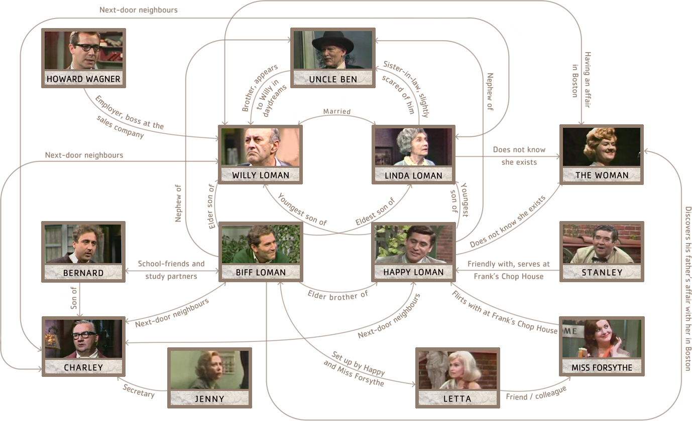
RELATIONSHIP MAP: VERSION 2

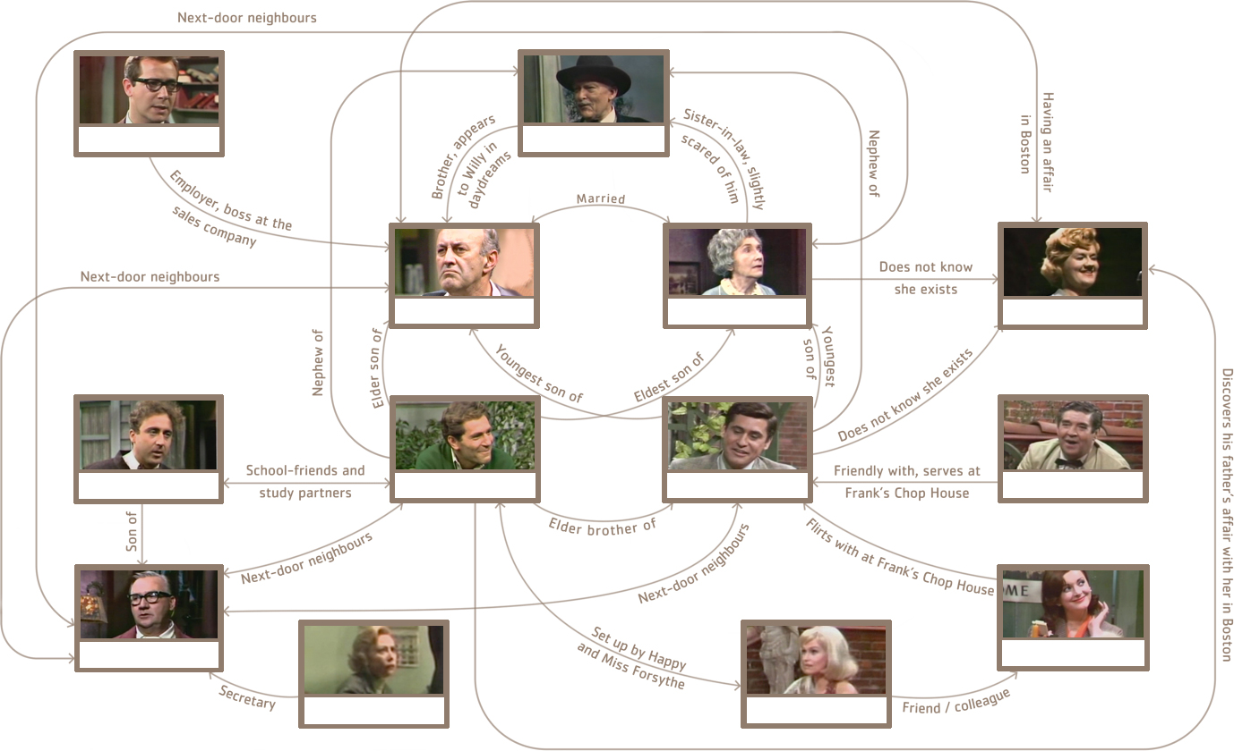
RELATIONSHIP MAP: VERSION 3

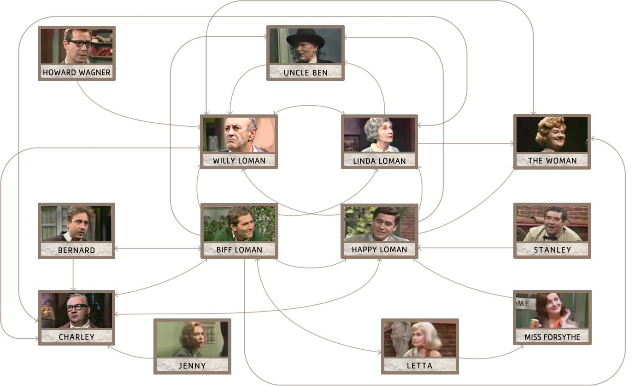
PLOT SUMMARY WORKSHEET

ACT 1

1) Where and when does the play take place?

2) At the beginning of the play, where is Willy Loman returning home from?

3) When Willy complains to Linda about Biff, what does he complain about?

4) When Willy talks to himself in the kitchen, what does this prompt Biff and Happy to discuss?

5) What do Biff and Happy fantasise about doing?

6) In Willy’s first dream in Act 1, what does he tell his sons he will do one day?

7) What does Bernard tell Biff during Willy’s dream?

8) How does Willy react to what Bernard says?

9) Later in Willy’s dream, when Linda asks about his day, how does he react?

First, Willy:
When Linda questions him, he admits:
Finally, Willy admits:

10) How does Linda treat Willy in his dream?

11) What happens as a result of Willy thinking of his mistress?

12) What does Willy try to get Bernard to do and how does Bernard respond?

13) When Happy comes downstairs and tries to quiet Willy, what does Willy feel regret about?

14) Why does Willy yell at Happy?

15) While Charley and Willy play cards, what does Charley offer Willy and what does Willy say?

16) Why does Charley leave?

17) What does Linda reveal to her sons that Charley has been doing?

18) At the end of the act, when Biff is speaking to his mother, what does he call his father?

19) What does Linda reveal about Willy’s car accidents and his overall
mental health?

20) What does Happy propose at the end of Act 1?

ACT 2

1) At the beginning of Act 2, what does Linda remind Willy to do?

2) Complete the sequence of events that occur in Howard’s office.

- Willy asks Howard:
- Howard insists:
- Willy reacts by:
- Howard then:

3) In Willy’s daydream, what does Ben ask Willy and what is Willy’s response?

4) What happens at Ebbets Field?

Biff:
Charley:
Willy:
5) While visiting Charley’s work, what does Bernard tell Willy he was always confused about?

6) What does Charley offer Willy and how does Willy react?

7) At the restaurant, what does Willy remember about Biff? Why is it important?

8) When Biff and Happy come home from the restaurant, why does Linda tell them to leave and never come back?

9) What happens between Biff and Willy in the garden?

When Biff says he’s leaving for good, Willy says:

Biff confesses:

Biff yells at Willy and urges him:
After Biff leaves, Willy brightens because:

10) What does Willy say to Ben in his hallucinatory conversation and how does Act 2 end?

REQUIEM

1) Why is Linda bewildered at the funeral?

2) What conflicting opinions about Willy do Biff and Charley express?

3) What does Happy decide at the end of the play?

4) What three things does Linda say at Willy’s grave?

- She tells him that she has made:
- She apologises:
- She says that the family is:

QUIZ QUESTIONS

- Who is the central character in the play?

- In Act 1, who said the following:

“It’s a measly manner of existence. To get on that subway on the hot mornings in summer. To devote your whole life to keeping stock, or making phone calls, or selling or buying. To suffer fifty weeks of the year for the sake of a two-week vacation, when all you really desire is to be outdoors, with your shirt off. And always to have to get ahead of the next fella. And still – that’s how you build a future.”

- Name a Shakespearean play that is often compared to Death of a Salesman.

- Name two things that the title Death of a Salesman refers to.

- As Willy hides from the realities of his life in memories and imagined conversations, Miller develops the theme of ?

- Who is the force of reason in the Loman family?

- The Mistress is also referred to as and
.

- Choose a character from the Word Bank and write their name next to their character flaw.

Character Bank
Ben | Biff | Happy | Linda | Willy

Character Flaw
Achieves no self-knowledge:
Is blindly loyal:
Is a petty thief:
Has unfounded self-confidence:
Thinks cheating is the only way to win:

- Which character serves as a representation of Willy’s weakness, infidelity and guilt?

- What does Charley give Willy every week?

- Which character exists to perpetuate the cycle of self-destruction?

- Willy believes that most important thing a man can be is .

- Ben discovered in Africa and as a result became a .

- Name two purposes served by the wire recorder Howard uses in Act 2.

- Who is Jenny?

- In Act 2 at the restaurant, Happy talks with the waiter and is later joined by his girlfriend and her friend
.

- In Act 2, who says “Where’s my stockings? You promised me stockings, Willy!”?

- At the end of Act 2, Biff tells Willy they are both not special men. He uses the phrase to describe their commonness.

- Fill in the name of the person who said the quote.

Quote | Who said it
“He’s not the finest character that ever lived. But he’s a human being, and a terrible thing is happening to him. So attention must be paid.” (Act 1)
“No, but it’s a business, kid, and everybody’s gotta pull his own weight.” (Act 2)
“A salesman is got to dream, boy. It comes with the territory.” (Requiem)
“He had a good dream. It’s the only dream you can have – to come out number-one man. He fought it out here, and this is where I’m gonna win it for him.” (Requiem)

- In Death of Salesman, Miller criticises what American ideal?

QUIZ QUESTIONS – MULTIPLE CHOICE

- Who is the central character of the play?
a) Happy Loman | c) Biff Loman
b) Willy Loman | d) Linda Loman

- In Act 1, who said the following:

“It’s a measly manner of existence. To get on that subway on the hot mornings in summer. To devote your whole life to keeping stock, or making phone calls, or selling or buying. To suffer fifty weeks of the year for the sake of a two-week vacation, when all you really desire is to be outdoors, with your shirt off. And always to have to get ahead of the next fella. And still – that’s how you build a future.”
a) Willy | c) Charley
b) Bernard | d) Biff

- Name a Shakespearean play that is often compared to Death of a Salesman.
a) Hamlet | c) King Lear
b) King John | d) Macbeth

- Name two things that the title Death of a Salesman refers to.
a) Death of American independence | d) Death of American Dream
b) Death of Willy | e) Death of Linda
c) Death of Biff | f) Death of American prosperity

- As Willy hides from the realities of his life in memories and imagined conversations, Miller develops the theme of ?
a) Pride | c) Escape
b) Jealousy | d) Ambition

- Who is the force of reason in the Loman family?
a) Linda | c) Happy
b) Willy | d) Biff
- The Mistress is also referred to as and
.
a) The Female, Miss Letta | c) The Lady, Miss Jenny
b) The Woman, Miss Francis | d) The Girl, Miss Forsythe

- Choose a character from the Word Bank and write their name next to their character flaw.

Character Bank
Ben | Biff | Happy | Linda | Willy

Character Flaw
Achieves no self-knowledge:
Is blindly loyal:
Is a petty thief:
Has unfounded self-confidence:
Thinks cheating is the only way to win:

- Which character serves as a representation of Willy’s weakness, infidelity and guilt?
a) The Mistress | c) The Neighbour
b) The Secretary | d) The Lawyer

- What does Charley give Willy every week?
a) Work | c) Money
b) Advice | d) Food

- Which character exists to perpetuate the cycle of self-destruction?
a) Ben | c) Howard
b) Bernard | d) Happy

- Willy believes that most important thing a man can be is .
a) Well behaved | c) Well dressed
b) Well liked | d) Well read

- Ben discovered in Africa and as a result became a .
a) Gold, success | c) Diamonds, millionaire
b) Silver, businessman | d) Platinum, trailblazer

- Name two purposes served by the wire recorder Howard uses in Act 2.
a) It establishes Howard’s successful financial position. | d) It explains what Howard’s business is.
b) It shows off Howard’s perfect family. | e) It illustrates Howard’s technical knowledge.
c) It demonstrates how multitalented Howard is.

- Who is Jenny?
a) Willy’s mistress | c) Biff’s girlfriend
b) Happy’s girlfriend | d) Howard’s secretary

- In Act 2 at the restaurant, Happy talks with the waiter and is later joined by his girlfriend and her friend
.
a) Bill, Letta, Jenny | c) Stanley, Miss Forsythe, Letta
b) Ben, Linda, Miss Forsythe | d) Bernard, Jenny, Linda

- In Act 2, who says “Where’s my stockings? You promised me stockings, Willy!”?
a) Linda | c) Jenny
b) The Woman | d) Miss Forsythe

- At the end of Act 2, Biff tells Willy they are both not special men. He uses the phrase to describe their commonness.
a) Blessing in disguise | c) Fit as a fiddle
b) Best of both worlds | d) Dime a dozen

- Draw a line from the name of the person who said the quote to the quote.

Quote | Who said it
“He’s not the finest character that ever lived. But he’s a human being, and a terrible thing is happening to him. So attention must be paid.” (Act 1) | Happy
“No, but it’s a business, kid, and everybody’s gotta pull his own weight.” (Act 2) | Howard
“A salesman is got to dream, boy. It comes with the territory.” (Requiem) | Linda
“He had a good dream. It’s the only dream you can have – to come out number-one man. He fought it out here, and this is where I’m gonna win it for him.” (Requiem) | Charley

- In Death of Salesman, Miller criticises what American ideal?
a) The American Dream | c) The American Pride
b) The American Spirit | d) The American Grit

SUGGESTED ASSIGNMENTS

CHARACTERS
Willy Loman is the central character and it’s often through his eyes that we see the world of the play. Some critics have suggested that the inevitability of Willy Loman’s death makes him a tragic hero.

ASSIGNMENT
Using the text of the play, respond to the following:
- “Willy is a bad father and cheating husband. He is not a tragic hero but an all-American villain.” Using details from the play, explain why this statement is true or false.
- Consider the play’s stage directions and, particularly, Willy’s flute music. How does Miller use the music to inform the way we think about Willy as a character?

EXTENSION QUESTION
- We never discover what product Willy actually sells. Why might this be?

Linda is the level-headed force of reason who attempts to keep the Loman family together. However, she is the most unknowable character in the play because we learn little of her interior life.

ASSIGNMENT
Using the text of the play, respond to the following:
- Do you think that “Miller’s writing of Linda is under-developed and gives her no real qualities of her own”? Explain why or why not.
- Linda often serves as a mediator between her sons and husband. How does Miller’s use of language equip her for this role?

Unlike his father, Willy, and brother, Happy, Biff is aware of his own failure, which he blames on his father. But by the end of the play, Biff is able to come to terms with his failure.

ASSIGNMENT
Using the text of the play, respond to the following:
- Is Biff right to blame Willy for his failure to succeed in the working world? Why or why not?
- Compare Biff’s relationship with his father to that with his mother. How does Miller change the ways in which Biff speaks to them? Why might
this be?
- “Biff is simultaneously the most tragic and the most hopeful character in the play”. Explain why you agree or disagree with this statement citing specific details in the play.

Happy has much in common with his father, Willy Loman. Happy has Willy’s unfounded self-confidence and he buys into Willy’s delusions and ambitions.

ASSIGNMENT
Using the text of the play, respond to the following:
- Do you think we are meant to like Happy as a character? Why or why not?
- Some people feel that “Willy may die, but Happy is the play’s greatest victim.” Explain why you agree or disagree with this statement.

EXTENSION QUESTION
- Compare Happy and Biff’s speech. In what ways does Miller differentiate the brothers through their dialogue?

Charley is Willy’s long-suffering neighbour, who is not exactly friends with the Loman family, but does his best to help Willy in his time of need.

ASSIGNMENT
Using the text of the play, respond to the following:
- Do you think that “Miller writes Charley to show the audience the opposite of Willy Loman”? Why or why not?
- Look at Charley’s monologue in the Requiem. What is its function and why is it important that it is Charley who says it?

In contrast to the sporty and popular Biff, Bernard is an academic type, constantly expressing his concern for Biff’s grades and encouraging him to study for math. But while Biff has grown up to be aimless and unfulfilled, Bernard has achieved great success as a lawyer.

ASSIGNMENT
Using the text of the play, respond to the following:
- Bernard, along with Howard Wagner and Uncle Ben, is one of the most professionally successful characters in the play. How does he differ from these characters? Why might this be?
- Compare and contrast the relationship between Bernard and Charley with that of Willy and Biff. How are they similar and how are they different?

Brave, risk-taking and lucky, Ben is Willy’s dead older brother.

ASSIGNMENT
Using the text of the play, respond to the following:
- What does Ben teach us about Willy’s relationship with his father, who is absent from the play?
- Willy may idolise his brother, but Linda is a little afraid of him. Why might this be? How is the audience/reader meant to feel about the character?

EXTENSION QUESTION
- Compare the character of Ben in Willy’s memory to his character in Willy’s imagined conversations with him. Analyse the differences in the two representations and discuss why you think they differ. How do the differences impact the audience/reader?

For the majority of the play, the audience knows Willy Loman’s mistress as The Woman, though later her refers to her as Miss Francis.

ASSIGNMENT
Using the text of the play, respond to the following:
- What is the significance of The Woman not being assigned a name for the majority of the play?
- Are we supposed to view The Woman as being to blame in Willy’s betrayal of Linda? Is there any sense in which we sympathise with her?

Howard is Willy’s much younger boss, having inherited the company from his father.

ASSIGNMENT
Using the text of the play, respond to the following:
- Are we intended to view Howard as a cruel character because of his firing of Willy? Cite specific details from the play which support your opinion.

- Consider the conversation Willy and Howard have about Howard’s father. What does their dialogue suggest about the differences between the father’s and son’s generations?

THEMES

THE AMERICAN DREAM
When we talk about the American Dream, we are talking about a national set of ideals that is seen to characterise life as it is lived in the United States. The phrase “American Dream” was popularised in 1931, described as a “… dream of a land in which life should be better and richer and fuller for every man, with opportunity for each according to his ability or achievement.”

ASSIGNMENT
Using the text of the play, respond to the following:
- In what ways might the American Dream as viewed by Miller in 1949 be different from the American Dream as we view it today?
- Death of a Salesman includes many “dream sequences” when Willy is lost in his own thoughts. How might these scenes reflect the play’s theme of the American Dream?

EXTENSION QUESTION
- Divide into groups, each choosing a different character from the play. How does the chosen character respond to the idea of the American Dream? Have they achieved it? Are they looking for it? Is the dream itself different for different people?

BETRAYAL

ASSIGNMENT
Using the text of the play, respond to the following:
- We tend to think of “betrayal” as an act committed by wicked, treacherous villains. Make a list of all the betrayals you can think of in the play and decide whether or not you think they are villainous. If not, what are they? Is there such a thing as a necessary betrayal?
- “No group of people betray one another more than families.” In what ways do the events of the play prove or disprove this statement? Cite specific evidence and details from the text to support your opinion.

LANGUAGE

THE TITLE

ASSIGNMENT
Using the text of the play, respond to the following:
- If you had to come up with another title for the play, what would it be and why?

EXTENSION QUESTION
- What did you think of the title when you hadn’t read the play? How has that changed now that you have and what about Miller’s writing might have prompted this change? Cite specific evidence from the text.

FIGURATIVE LANGUAGE AND IMAGERY
Figurative language is language where the meaning is not literal; the words mean something else other than their literal definition. In Death of a Salesman, Miller uses figurative language to assist him in strengthening the themes of the play.

ASSIGNMENT
Using the text of the play, respond to the following:
- Find three examples of figurative language in the play. Why has Miller chosen these specific words rather than any other expression?
- What images can you think of which recur throughout the play? How might we read them symbolically?

CONTEXT

POST-WWII AMERICA
The post-WWII era in the United States was a period of great economic prosperity. But not everyone benefited. The poorest citizens’ situations didn’t improve and, in fact, higher inflation made it harder for them to save money. But financial shifts weren’t the only changes. The mindset of society shifted. There was a new social desire to conform to the norms and values of the majority and other people’s perceptions became a greater factor in influencing behaviour.

ASSIGNMENT
Using the text of the play, respond to the following:
- Should we read the character of Willy Loman as a kind of “everyman” figure?
- Read the complete section from the Study Guide on “Context: Post-WWII America”. This section explores how the play spoke to the specific social circumstances of 1949. Which issues might the play speak to when it is performed today?

EXTENSION QUESTION
- In pairs, debate whether Death of a Salesman is a “family drama” or a “political drama”. What might the features of these two genres be? Can a play be both? Cite specific evidence from the text to support your opinion.

PLOT SUMMARY WORKSHEET – ANSWERS

ACT 1

1) Where and when does the play take place?

Brooklyn, New York 1949 / post-WWII

2) At the beginning of the play, where is Willy Loman returning home from?

A failed sales trip

3) When Willy complains to Linda about Biff, what does Willy complain about?

Willy complains that Biff has failed to live up to the potential he showed as a star athlete in high school.

4) When Willy talks to himself in the kitchen, what does this prompt Biff and Happy to discuss?

Willy’s deteriorating mental health

5) What do Biff and Happy fantasise about doing?

Buying a ranch together in the West

6) In Willy’s first dream in Act 1, what does Willy tell his sons he will do one day?

He will open a business bigger and more successful than that owned by his neighbour, Charley.

7) What does Bernard tell Biff during Willy’s dream?

That Biff must study for his math class in order to avoid failing.

8) How does Willy react to what Bernard says?

Willy treats Bernard’s recommendation and his overall intelligence as unimportant. Willy tells his sons that Bernard may be smart but he isn’t “well liked” like Happy and Biff are.

9) Later in Willy’s dream, when Linda asks about his day, how does he react?

First, Willy: brags of unprecedented success.
When Linda questions him, he admits: that he only made a fraction of what he claimed.
Finally, Willy admits: he’s worried he’s not good at his job.

10) How does Linda treat Willy in his dream?

Linda refuses to believe he isn’t good at his job. She tells him how handsome he is.

11) What happens as a result of Willy thinking of his mistress?

Seeing Linda mending her stockings makes him feel guilty because he gave new stockings to his mistress, but his wife is mending old ones. As a result, he yells at Linda for mending her stockings and tells her to throw them away.

12) What does Willy try to get Bernard to do and how does Bernard respond?

Willy tries to get Bernard to give Biff the answers to the test, but Bernard tells Willy no, that he could get arrested for doing so.
13) When Happy comes downstairs and tries to quiet Willy, what does Willy feel regret about?

Willy regrets not moving to Alaska with his brother Ben.

14) Why does Willy yell at Happy?

Willy says Happy will never be able to look after him on a salary of $70 a week while he’s busy living a lifestyle of women and cars.

15) While Charley and Willy play cards, what does Charley offer Willy and what does Willy say?

A job; Willy turns him down

16) Why does Charley leave?

Willy accuses Charley of cheating while they’re playing cards.

17) What does Linda reveal to her sons that Charley has been doing?

Giving Willy money to pay the bills

18) At the end of the act, when Biff is speaking to his mother, what does Biff call his father?

A fake

19) What does Linda reveal about Willy’s car accidents and his overall mental health?

She thinks the car accidents are suicide attempts and that Willy has also attempted to asphyxiate himself. She thinks his mental imbalance stems from him having lost his salary.

20) What does Happy propose at the end of Act 1?

That he and Biff open a sporting goods business together.

ACT 2

1) At the beginning of Act 2, what does Linda remind Willy to do?

She reminds him to go visit Howard Wagner and to ask Howard to give him a non-travelling job.

2) Complete the sequence of events that occur in Howard’s office.

- Willy asks Howard: for a desk job in New York.
- Howard insists: no such jobs exist and there’s nothing he can do.
- Willy reacts by: becoming frustrated and angry.
- Howard then: fires Willy.

3) In Willy’s daydream, what does Ben ask Willy and what is Willy’s response?

Ben asks Willy to go to Alaska with him. Linda and Willy maintain that Willy will make his fortune without leaving New York.

4) What happens at Ebbets Field?

Biff: plays his big football game.
Charley: mocks Willy for the importance he places on the game .
Willy: becomes furious with Charley.

5) While visiting Charley’s work, what does Bernard tell Willy he was always confused about?

He is confused as to why Biff didn’t retake maths in summer school, having been set on doing so until a visit to Willy in Boston, after which he gave up hope of going to college.

6) What does Charley offer Willy and how does Willy react?

Charley offers Willy a job again and again Willy refuses. Willy gets angry and leave the office in tears.

7) At the restaurant, what does Willy remember about Biff? Why is it important?

Willy remembers Biff finding him with his mistress. Biff accuses Willy of giving Linda’s stockings to the mistress and calls his father a phony liar. The scene is important because it explains why Biff never retook his maths and didn’t go to college.

8) When Biff and Happy come home from the restaurant, why does Linda tell them to leave and never come back?

Because they left Willy alone in the restaurant bathroom .

9) What happens between Biff and Willy in the garden?

When Biff says he’s leaving for good, Willy says: that Biff is throwing his
life away.
Biff confesses: that he was in prison for three months for having stolen a suit.
Biff yells at Willy and urges him: to accept his commonness.
After Biff leaves, Willy brightens because: Biff cried and therefore he concludes that Biff must like him.

10) What does Willy say to Ben in his hallucinatory conversation, and how does Act 2 end?

Willy talks with Ben about how far Biff could go with the $20,000 from his life insurance policy and that he is contemplating suicide so his family can cash it in. He speeds away in a car to commit suicide.

REQUIEM

1) Why is Linda bewildered at the funeral?

Because the Loman family, Charles and Bernard are the only mourners at Willy’s funeral and she wonders where all the friends he bragged about are.

2) What conflicting opinions about Willy do Biff and Charley express?

Biff states that Willy never really knew who he was and had all the wrong dreams. In contrast, Charley defends Willy, saying that a salesman has to dream or he is lost.

3) What does Happy decide at the end of the play?

To stay in the city and fulfil Willy’s dreams by becoming a top businessman.

4) What three things does Linda say at Willy’s grave?

- She tells him that she has made: the last payment on the house.
- She apologises: for not being able to cry.
- She says that the family is: finally free.

QUIZ QUESTIONS – ANSWERS

- Who is the central character in the play?
Answer: Willy Loman

- In Act 1, who said the following:

“It’s a measly manner of existence. To get on that subway on the hot mornings in summer. To devote your whole life to keeping stock, or making phone calls, or selling or buying. To suffer fifty weeks of the year for the sake of a two-week vacation, when all you really desire is to be outdoors, with your shirt off. And always to have to get ahead of the next fella. And still – that’s how you build a future.”
Answer: Biff

- Name a Shakespearean play that is often compared to Death of a Salesman.
Answer: King Lear

- Name two things that the title Death of a Salesman refers to.
Answer: Willy’s death, the death of Willy’s dream, the death of the American people’s dreams in an unjust financial system

- As Willy hides from the realities of his life in memories and imagined conversations, Miller develops the theme of ?
Answer: escape

- Who is the force of reason in the Loman family?
Answer: Linda

- The Mistress is also referred to as and
.
Answer: The Woman; Miss Francis
- Choose a character from the Word Bank and write their name next to their character flaw.

Character Bank
Ben | Biff | Happy | Linda | Willy

Answers:
Achieves no self-knowledge: Willy
Is blindly loyal: Linda
Is a petty thief: Biff
Has unfounded self-confidence: Happy
Thinks cheating is the only way to win: Ben

- Which character serves as a representation of Willy’s weakness, infidelity and guilt?
Answer: The Woman / The Mistress / Miss Francis

- What does Charley give Willy every week?
Answer: Money; $50

- Which character exists to perpetuate the cycle of self-destruction?
Answer: Happy

- Willy believes that most important thing a man can be is .
Answer: well liked

- Ben discovered in Africa and as a result became a .
Answer: diamonds, millionaire (or success)

- Name two purposes served by the wire recorder Howard uses in Act 2.
Answer: It makes him distracted so he doesn’t have any real time for Willy. It establishes Howard’s financial position because it’s a modern, expensive gadget; this is a contrast to Willy’s financial position. It shows off his perfect family, which contrasts with Willy’s.

- Who is Jenny?
Answer: Howard’s secretary

- In Act 2 at the restaurant, Happy talks with the waiter and is later joined by his girlfriend and her friend
.
Answer: Stanley, Miss Forsythe, Letta

- In Act 2, who says “Where’s my stockings? You promised me stockings, Willy!”?
Answer: The Woman

- At the end of Act 2, Biff tells Willy they are both not special men. He uses the phrase to describe their commonness.
Answer: dime a dozen

- Fill in the name of the person who said the quote.

Answers:
Quote | Who said it
“He’s not the finest character that ever lived. But he’s a human being, and a terrible thing is happening to him. So attention must be paid.” (Act 1) | Linda
“No, but it’s a business, kid, and everybody’s gotta pull his own weight.” (Act 2) | Howard
“A salesman is got to dream, boy. It comes with the territory.” (Requiem) | Charley
“He had a good dream. It’s the only dream you can have – to come out number-one man. He fought it out here, and this is where I’m gonna win it for him.” (Requiem) | Happy

- In Death of Salesman, Miller criticises what American ideal?
Answer: The American Dream

QUIZ QUESTIONS – MULTIPLE CHOICE ANSWERS

- Who is the central character of the play?
a) Happy Loman | c) Biff Loman
b) Willy Loman | d) Linda Loman

- In Act 1, who said the following:

“It’s a measly manner of existence. To get on that subway on the hot mornings in summer. To devote your whole life to keeping stock, or making phone calls, or selling or buying. To suffer fifty weeks of the year for the sake of a two-week vacation, when all you really desire is to be outdoors, with your shirt off. And always to have to get ahead of the next fella. And still – that’s how you build a future.”
a) Willy | c) Charley
b) Bernard | d) Biff

- Name a Shakespearean play that is often compared to Death of a Salesman.
a) Hamlet | c) King Lear
b) King John | d) Macbeth

- Name two things that the title Death of a Salesman refers to.
a) Death of American independence | d) Death of American Dream
b) Death of Willy | e) Death of Linda
c) Death of Biff | f) Death of American prosperity

- As Willy hides from the realities of his life in memories and imagined conversations, Miller develops the theme of ?
a) Pride | c) Escape
b) Jealousy | d) Ambition

- Who is the force of reason in the Loman family?
a) Linda | c) Happy
b) Willy | d) Biff

- The Mistress is also referred to as and
.
a) The Female, Miss Letta | c) The Lady, Miss Jenny
b) The Woman, Miss Francis | d) The Girl, Miss Forsythe

- Choose a character from the Word Bank and write their name next to their character flaw.
Character Bank
Ben | Biff | Happy | Linda | Willy

Answers:
Achieves no self-knowledge: Willy
Is blindly loyal: Linda
Is a petty thief: Biff
Has unfounded self-confidence: Happy
Thinks cheating is the only way to win: Ben

- Which character serves as a representation of Willy’s weakness, infidelity and guilt?
a) The Mistress | c) The Neighbour
b) The Secretary | d) The Lawyer

- What does Charley give Willy every week?
a) Work | c) Money
b) Advice | d) Food

- Which character exists to perpetuate the cycle of self-destruction?
a) Ben | c) Howard
b) Bernard | d) Happy

- Willy believes that most important thing a man can be is .
a) Well behaved | c) Well dressed
b) Well liked | d) Well read

- Ben discovered in Africa and as a result became a .
a) Gold, success | c) Diamonds, millionaire
b) Silver, businessman | d) Platinum, trailblazer

- Name two purposes served by the wire recorder Howard uses in Act 2.
a) It establishes Howard’s successful financial position. | d) It explains what Howard’s business is.
b) It shows off Howard’s perfect family. | e) It illustrates Howard’s technical knowledge.
c) It demonstrates how multitalented Howard is.

- Who is Jenny?
a) Willy’s mistress | c) Biff’s girlfriend
b) Happy’s girlfriend | d) Howard’s secretary

- In Act 2 at the restaurant, Happy talks with the waiter and is later joined by his girlfriend and her friend
.
a) Bill, Letta, Jenny | c) Stanley, Miss Forsythe, Letta
b) Ben, Linda, Miss Forsythe | d) Bernard, Jenny, Linda

- In Act 2, who says “Where’s my stockings? You promised me stockings, Willy!”?
a) Linda | c) Jenny
b) The Woman | d) Miss Forsythe

- At the end of Act 2, Biff tells Willy they are both not special men. He uses the phrase to describe their commonness.
a) Blessing in disguise | c) Fit as a fiddle
b) Best of both worlds | d) Dime a dozen

- Draw a line from the name of the person who said the quote to the quote.

Answers:
Quote | Who said it
“He’s not the finest character that ever lived. But he’s a human being, and a terrible thing is happening to him. So attention must be paid.” (Act 1) | Linda
“No, but it’s a business, kid, and everybody’s gotta pull his own weight.” (Act 2) | Howard
“A salesman is got to dream, boy. It comes with the territory.” (Requiem) | Charley
“He had a good dream. It’s the only dream you can have – to come out number-one man. He fought it out here, and this is where I’m gonna win it for him.” (Requiem) | Happy

- In Death of Salesman, Miller criticises what American ideal?
a) The American Dream | c) The American Pride
b) The American Spirit | d) The American Grit

